

DISTRICT HEALTH PLANNING AND MONITORING FRAMEWORK

(INCLUDES GUIDELINES AND TEMPLATES FOR DISTRICT HEALTH PLANS 2018/19-2020/21)

August 2017

# FOREWORD BY THE DIRECTOR-GENERAL

The Government’s vision for 2014-2019 is to achieve a “long and healthy life for all South Africans”, defined by the Medium Term Strategic Framework 2014-2019, National Development Plan 2030 and Sustainable Development Goal 3.

South Africa has opted for a decentralised District Health System to deliver primary health care. The National Department of Health has a policy mandate for the National Health System of South Africa, while the health services rendered by the District Health System are managed by Provincial Departments of Health.

District health management team’s fundamental responsibility is planning for health needs and demands of their communities. District health planning also requires effective health management information systems that are of fundamental importance in assessing district health needs; allocation of resources and monitoring of their use; monitoring of the utilization of services, their quality and coverage; and policy formulation and programme evaluation.

While the statutory framework is coherent and ensures alignment between planning, budgeting, monitoring and evaluation; it however, does not adequately enable the country’s development objectives. Planning seems to have become more of a compliance exercise, consuming vast amounts of time and energy with limited success in advancing the aspiration of the National Development Plan.

The National DoH has revised the District Health Planning framework in partnership with all Provincial DoH, even though, the National Health Act, 61 of 2003 mandates the Director-General to develop and issue national guidelines for District Health Plans. We have strived to improve the effectiveness and efficiency of planning, and monitoring in this revised framework. Going forward, the district planning and monitoring focusses on the planning, critical thinking and learning process, as opposed to the production of a District Health Plan, which now becomes a secondary requirement.

My appreciation goes to the District Health Planning Technical Working Group that steered the production of this framework, as well as, contributions of the National Strategic Planning Committee (NSPC) and National District Health Systems Committee (NDHSC) throughout the process. I would also like to acknowledge dedicated District Health Management Teams throughout the country, who play an important role in the management and delivery of primary health care services.

I anticipate provincial managers responsible for Strategic Planning, Monitoring and Evaluation, District Health Services at provincial head offices to support, and their respective District Management Teams to implement these guidelines.

I will provide leadership and oversight to implement this framework with support from Technical advisory committee of the National Health Council.

_______________________

Ms MP Matsoso  
Director-General: Health  
Date: 25 Aug 2017

# ACKNOWLEDGEMENTS

A Technical Working Group (TWG) was established for strengthening District Planning and Monitoring at the National DoH during April 2016. It later expanded to Provincial DoH by co-opting members from the National Strategic Planning Committee, and National District Health System Committee. It consists of the following officials:

**National DoH:**

Deputy Director-Generals (DDGs)

The following are acknowledged for their guidance and support:

* Dr Gail Andrews – Chief Operations Officer
* Dr Yogan Pillay – DDG: TB, HIV and MNCH
* Ms Jeanette Hunter – DDG: Primary Health Care and Environmental Health Services

Technical Working Group

* Mr Gaurang Tanna - Policy co-ordination and Integrated Planning Cluster (Convenor)
* Ms Roanda Pretorius - Policy co-ordination and Integrated Planning Cluster
* Mr Ramphelane Morewane – District and Development Cluster
* Mr Bennett Asia – District and Development Cluster
* Dr Andrew Crichton – Human Resource for Health Cluster
* Mr Hadley Nevhutalu – Provincial Financial Management Unit
* Mr Nthabiseng Khoza – HIV/AIDS Conditional Grant Manager
* Dr Lesley Bamford – Child Health Cluster

Independent Consultants

* Dr Shuaib Kauchali – Technical Advisor for Child Health
* Dr Carol Marshall – National Co-coordinator of District Clinical Specialist Teams (DCSTs)
* Dr Peter Barron – Independent consultant

**Provincial DoH:**

* Dr Singilizwe Moko – District Health Services, Eastern Cape DoH
* Dr Grace London – District Health Services, Free State DoH
* Ms Karen Ching – Strategic Planning, Western Cape DoH
* Ms Ester Snyman – Strategic Planning, KwaZulu-Natal DoH
* Mr John Molokwane – Strategic Planning, Limpopo DoH

**Contributions from Non-governmental Organisations (NGOs) and development partners**

* Ms Romy Overmeyer – FPD
* Dr Sanjana Bhardwaj – UNICEF
* Dr Joey Cupido – UNICEF
* Ms Latasha Treger – UNICEF
* Dr D Nhemachema – Aurum
* Mr P McLachan – Aurum
* Ms Tharina Gombault – Accenture

# CONTACT DETAILS:

All queries on these guidelines may be directed to the National Department of Health on email [DHP@health.gov.za](mailto:DHP@health.gov.za).

The District Management Teams may also submit their final draft District Health Plans for 2018/19-2020/21 (due end January 2018) with a cover letter signed by District Manager or Provincial Head of Department, addressed to Director-General on email address: [DHP@health.gov.za](mailto:DHP@health.gov.za)

Ms MP Matsoso

Director-General: Health

Tel: 012 395 9150

Mr Gaurang Tanna

Cluster: Policy co-ordination and Integrated Planning

National Department of Health

Tel: 012 395 8408

Email: [Gaurang.Tanna@health.gov.za](mailto:Gaurang.Tanna@health.gov.za)

Mr Bennett Asia

Cluster: District Health Services

National Department of Health

Tel: 012 395 8760

Fax: 012 395 8763

Email: [Bennett.Asia@health.gov.za](mailto:Bennett.Asia@health.gov.za)

Contents

FOREWORD BY THE DIRECTOR-GENERAL 2

ACKNOWLEDGEMENTS 3

CONTACT DETAILS: 4

PART A – District Health Planning and Monitoring Framework 8

1. BACKGROUND 8

2. INTRODUCTION 8

3. OUTCOME BASED PLANNING 9

3.1 Components for Bottleneck analysis 10

3.2 Logic Model 10

3.3 Impact Calculator 11

3.4 Population Prioritisation Matrix 11

3.5 Patient care pathways, referral system and care continuum 12

4. HEALTH SECTOR PLANNING SYSTEM 12

4.1 Medium Term Plans 13

4.2 Short-term Plans 13

5. DISTRICT HEALTH PLANNING AND MONITORING 14

5.1 Epidemiology 15

5.2 District Planning Framework 16

5.3 District Monitoring Framework 18

6. WHO: roles and responsibilities of provincial office and District management 19

6.1 Provincial co-ordination and support to Districts 19

6.2 District Planning, Monitoring and Response Forums 19

6.2.1 District Forums 20

6.2.2 Sub-District forums 21

7. WHEN: timeframes for the 2018/19 planning cycle 22

8. Alignment between Provincial Annual Performance Plans, and District Health Plans 23

9. Alignment between District Implementation Plan (DIP) process and District Planning Framework 23

PART B – DISTRICT HEALTH STRATEGIC PLANNING PROCESS 25

Step 1 – What is our Aspiration? 26

Process 26

Templates 26

Step 2 – Diagnosis: Where are we now, and why are we here? 28

Step 2 A – Where are we now? (Outcome/Coverage Indicators) 28

Theory of Change (Coverage) Indicators: 28

STEP 2 B – Where are we now? (Quality indicators) 29

Process 29

Tool 1: PHC Facilities - Ideal Clinic software 29

Other challenges (Bottlenecks) 31

Tool 2: Hospitals - National Core Standards: 32

Tool 3: Consolidated Death Report 33

Tool 4: Patient Experience of Care Survey 34

STEP 2C – Why are we here? 34

Process 35

Tools: 35

Tool 1: The Fishbone Analysis (Root cause analysis) 35

The Five Whys Technique 37

Problem Tree 37

Template for Bottlenecks and Root-causes, linked to District Aspirations: 38

Summarise Bottlenecks and Root-causes in the template below along with the corresponding aspiration: 38

Step 3 Focus for Impact: Where will we play? 39

Tools - Where will we Play? 39

Tool 1. Causes of mortality 39

Tool 2 – Sub-District Indicator Table 40

Step 4 –Focus for impact: How will we win? 41

Template: Where will we play and How will we win? 41

Step 5-Resource allocation: What do we need, How much? 42

Process – Recruitment prioritisation of Employees 42

Process – budgeting for goods and services 42

Tool: Recruitment Prioritisation 43

Facility Template 43

District Template – Decision matrix to prioritise vacant posts 44

1. EXECUTIVE SUMMARY BY THE DISTRICT MANAGER 46

2. ACKNOWLEDGEMENTS 46

3. OFFICIAL SIGN OFF 46

4. EPIDEMIOLOGICAL PROFILE 47

5. SERVICE DELIVERY PLATFORM AND MANAGEMENT 47

6. QUALITY OF CARE 47

7. ORGANISATIONAL STRUCTURE OF THE DISTRICT MANAGEMENT TEAM 47

8. DISTRICT HEALTH EXPENDITURE 47

9. DISTRICT ASPIRATIONS AND INDICATOR TARGETS 48

10. BOTTLENECKS AND ROOT CAUSES 49

11. KEY INTERVENTIONS 50

ANNEXURE A: Targets for Sustainable Development Goal 3 – “Good Health and Well-Being” 52

ANNEXURE B: Consolidated Death Report Template for Maternal, Neonatal / Perinatal and Child Mortality (Example) 53

Annexure C: Comprehensive Health Information to conduct situational analysis 67

ANNEXURE D: PowerPoint slides for District Planning and Monitoring Framework, methods, process, and templates 75

# PART A – District Health Planning and Monitoring Framework

# BACKGROUND

In order to strengthen District Planning and Monitoring, the National Department of Health established a Technical Working Group (TWG) in April 2016. It later expanded to Provincial DoH by co-opting members from the National Strategic Planning Committee (NSPC), and National District Health System Committee(NDHSC). The Technical Working Group developed a discussion paper describing public health sector’s planning system. The discussion paper has documented the challenges experienced, some of their root causes and recommendations to “Strengthen District Planning and Monitoring”. The recommendations were presented and adopted by Technical National Health Council (TechNHC) on 11 August 2016.

The National DoH facilitated two workshops subsequently with Provincial DOH. The first workshop took place on 28 and 29 September 2016. It was attended by core members of the Technical Working Group (with selected District Managers nominated by Provincial DoH), and members of the National Strategic Planning Committee. The second workshop took place in the form of combined NSPC and NDHSC meeting on 5th and 6th July 2017. This workshop unpacked a fresh approach to District Planning, Implementation and Monitoring by discussing the District Planning methods, time frames with role and responsibility.

# INTRODUCTION

Despite making some progress towards the targets of Millennium Development Goals 4, 5 and 6, South Africa’s performance raises concerns and more needs to be done. The Department has made progress to align plans between districts provinces and national, in that the entire health system is targeting a common (core) set of indicators.

Challenges however exist in that the district and provincial plans are at a high level and often do not respond to the interventions/ activities required to improve service delivery and deliver better outcomes. We often attribute our failures to political climate, funding issues and lack of staff, with little recognition of the failure to plan effectively and use the available resources more effectively and efficiently.

The aim of this fresh approach is to:

1. Transform district health planning and monitoring into a unified (integrated) action plan; and
2. Respond to both programmatic priorities (clinical governance, clinical protocols, standard treatment guidelines, etc.) and health system priorities (Ideal Clinic - HR, Infrastructure, finance, Information, etc.),

in order to improve **access** and achieve better **quality** of care resulting in improved health **outcomes**.

This new approach therefore improves the quality of the District Plans by strengthening the depth of planning and monitoring and decision-making for health outcomes. The objectives are to achieve:

1. Better priority setting and evidence-based decision making at District level that unlock bottlenecks and deliver health outcomes (macro planning);
2. Alignment of District targets (of core indicators) with Provincial Annual Performance Plans, and disaggregating District targets to sub-districts and health facilities, especially hospitals (top-down planning);
3. Meaningful action plans at local levels (facility, sub-district and district) that are costed and that guide implementation and monitoring to achieve targets (bottom up and micro planning);
4. Closer monitoring of performance to improve data quality resulting in better audit outcomes for performance information and evidenced-based macro and micro planning;
5. Established reporting and feedback mechanisms at local level (District and below), and between District and Province.

These guidelines recognize that District Planning, Budgeting, and Monitoring is a single objective and it therefore strives to streamline the process. The revised District Planning and monitoring system is an effort to improve both efficiency and effectiveness of the process, thereby promoting better service delivery of District Health Services and improve health outcomes in South Africa through a direct focus on planning and monitoring for implementation.

# OUTCOME BASED PLANNING

The National Development Plan (NDP) and SDG 3 are umbrella plans of government and the health sector. The NDP sets out nine (9) long-term health goals for South Africa. Five of these goals relate to improving the health and well-being of the population, and the other four deals with aspects of health systems strengthening.

In September 2015, countries (including South Africa) committed to 17 goals aimed at ending poverty, protecting the planet and ensuring prosperity for all as part of the new global development agenda. Each of the 17 goals has a set of specific targets which countries must achieve by 2030.

**Targets for Goal 3:** “Good Health and Well-Being” is provided under Annexure A. In this, the critical importance of health as one of the fundamental human rights and its contribution to human development means that South Africa is also guided by the commitments made by the United Nations in the form of the Sustainable Development Goals to which South Africa is a signatory. The survival, health and well-being of women, children and adolescents (thrive and transform) are essential to achieving all the Sustainable Development Goals (SDGs).

 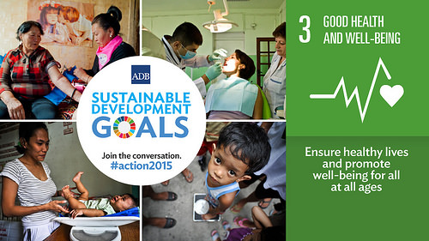

National Development Plan 2030 Sustainable Development Goals 2030

There are high levels of overlap and alignment between the National Development Plan 2030 adopted by the Government of South Africa in 2013, and the Sustainable Development Goals adopted by United Nations during September 2015.

**The Medium Term Strategic Framework 2014-2019 for Outcome 2** provides strategic actions that health sector will carry out to attain the targets required by the NDP and SDG.

The Department of Health’s main function is to:

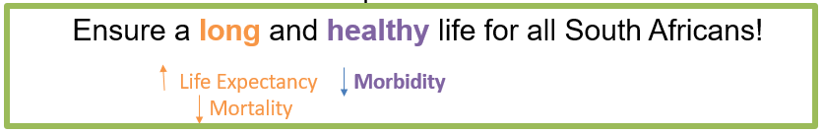

**Every death counts.** It is everybody’s business to reduce deaths, and illness in our country. The planning, and monitoring system of the health sector (at all levels) must therefore ensure that the planning and monitoring systems responds to this fundamental function. At the most elementary level, the health systems must plan for these three main variables:

* 1. Community (includes people/patients)
  2. Health statusof the community (manage diseases)
  3. Service delivery platforms (manage provision of health services through a defined service platform)

The **life course approach** considers people living with different structural, social and cultural contexts throughout their lives, whilst, **the illness condition approach** considers a programmatic perspective of rendering health services in response to certain conditions/illnesses. In addition to the morbidity and mortality of the population, the system itself must also be considered as we move forward towards NHI in creating an enabling environment for the provision of health services. The health planning and monitoring framework must therefore **combine these three approaches; life course, illness/condition and systems** for understanding vulnerable groups that require attention and creating the supply required to meet this need. District goals, or Aspirations, will be structured based on these three approaches as well. Districts will have Aspirations in relation to mortality, morbidity and health systems strengthening.

## Components for Bottleneck analysis

In order to leverage a consistent framework for understanding and categorising challenges within service delivery, the 10 components of the Ideal Clinic Methodology will be used. These components are comprehensive and can be used in a similar way to the prongs of a fishbone analysis, the blocks in the 2X4 DIP matrix, the blocks in the 3X4 3-feet Approach, and the WHO Health System Strengthening building blocks. It is important to use consistent components in order to align interventions and build a reference structure to ensure consistency. This will enable software to be developed to support the planning, implementation and monitoring processes across programs and platforms.

## Logic Model

The South African Government has adopted the logic model as its framework for all performance information. This performance information framework is applicable to planning, monitoring and evaluation. It can be used to define what must be delivered to get impact and understand the effort that will bring the results. The logic framework may then also be used to track implementation of your strategy and operational plan.

Effective logic model make an explicit statement of the activities that will bring about change and the results we expect to see with respect to health outcomes for the population we are serving. Indicators are mapped to this logic model and should be used to monitor elements along the framework.

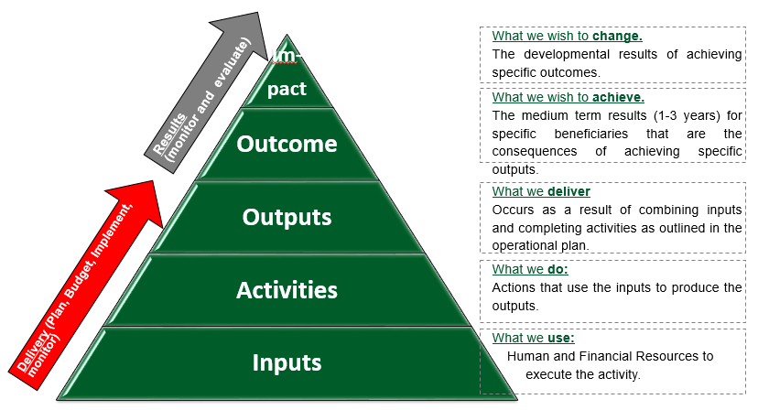

**Source: Adapted from Framework for Managing Programme Performance Information (FMPPI), 2007**

## Impact Calculator

In order to achieve programme impact, the key interventions have to reach all those in needs delivered through strong service delivery platform at high quality. To reach the target population, all barriers to access should be removed and specific focus on improving community acceptability (creating demand for services) should be addressed. Better clinical care, governance, health care workers’ skills, and competency are necessary requirements to deliver high quality services. An enabling administrative and working environment are both critical to achieving high quality of care and access to care. This complex relationship is illustrated in the “impact calculator”, described by Tanahashi 1978, in the figure below:

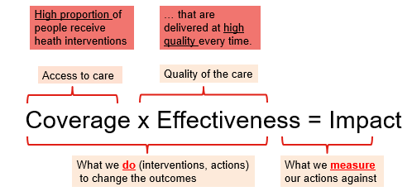

**Source: Adapted from Tanahashi, 1978**

## Population Prioritisation Matrix

The population prioritisation matrix combines the life course and illness/conditions approaches to District Planning. The population groups (rows) intersect with illness (or health conditions) (columns) affecting individuals within communities. All planning processes and systems should support programme effectiveness through addressing the needs of the target population. The population priority matrix (below diagram) is used to identify mortality and morbidity outcomes and measures of success (indicators), and is useful in showing how planning and monitoring processes yield impact.

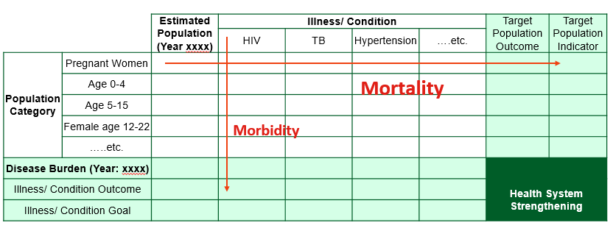

During planning, each target population’s baseline measure of outcome (along the horizontal), for example, institution maternal mortality ratio (iMMR), should be assessed and an annual performance target set; during the implementation of the plan, progress towards the target should be monitored. Similarly, morbidity target should also be set along the vertical axis, for example, for HIV testing coverage, or HIV incidence rates across the entire population groups.

Within each cell, four dimensions (Prevention, Case identification, Treatment initiation and Treatment success) need to be considered. So, for example, for Under 5 mortality as a result of HIV, the participants should identify challenges in preventing HIV, identifying those that are HIV positive, ensuring they are placed on treatment, and that the treatment is successful.

## Patient care pathways, referral system and care continuum

The health outcomes are patient centric, while our service delivery platforms are managed administratively. The patients may cross administrative boundaries and jurisdictions at times, however, these should not compromise the health outcome. This requires the District Health System to plan with referral hospitals (regional, tertiary and central) to ensure that health services are collectively delivered and health outcomes are collectively derived.

The District Clinical Specialist Teams also function across the care continuum. They are expected to produce a **consolidated death report**, that includes an analysis of all in facility deaths, their causes and modifiable factors leading to mortality.

# HEALTH SECTOR PLANNING SYSTEM

There has been significant progress over the last decade to create greater alignment between national, provincial and district plans. A core set of indicators form the backbone of plans across the spheres of government, and we are working toward achieving the same goals.

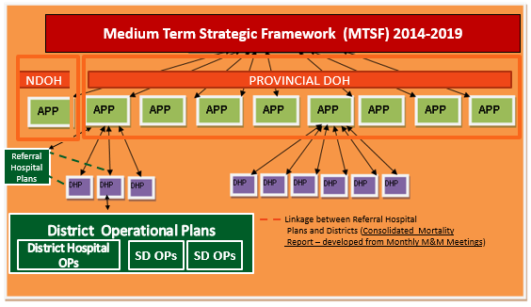

## Medium Term Plans

#### Medium Term Strategic Framework (MTSF)

This framework is the overarching strategic plan for the health sector and is the main vehicle for translating the objectives of the NDP and SDG into a set of priority actions. MTSF informs the statutory plans required for both the national and provincial spheres of government.

#### Strategic Plans

National and provincial sector departments are required by law to produce 5 year strategic plans which coincide with the electoral cycle, and must reflect the broad strategic outcomes of government. These plans are founded on the legislative mandates that the department is directly responsible for implementing and managing, giving effect to the statutory responsibilities of the department. Strategic plans are meant to be tools that enable departments to priorities and plan the incremental implementation of more long term strategic intentions. Currently both the provincial and the national spheres of government in the health sector have these plans in place, responding to health delivery mandate for provincial DoH and policy and oversight mandates for National DoH.

National and Provincial Departments also develop disease specific (HIV AIDS, TB) Strategies and strategies targeting health programmes for specific populations (Maternal Neonatal Child and Womens Health).

## Short-term Plans

#### Annual Performance Plans (APP)

These annual plans document the intentions of departments in the coming financial year and during the Medium Term Expenditure Framework (MTEF) to implement their strategic plan. The plan captures the performance indicators and targets for budget programmes and provides a basis for evaluating the performance of the department. These indicators and targets need to be aligned across the annual plans, budgets, in-year and annual reports. Currently both the provincial and the national spheres of government in the health sector have these plans in place.

#### District Health Plans (DHP)

There is a statutory requirement for districts to have annual plans that are approved by their District Health Council, and Provincial Head of Department. DHPs are required to include service, human resource, financial and infrastructure plans with specific indicators and targets, for the coming financial year. Currently all districts compile DHPs and submit to Provincial and National Department of Health. These plans are not regulated by PFMA, are thus currently not subject to auditing by the AG.

#### Operational and Work Plans

The National DoH and Provincial DoH also develop Operational Plans and/or work plans to implement their respective Annual Performance Plans.

#### Other Plans

There are a number of plans that are required in addition to the above with regard to human resources, infrastructure and ICT, as well as, plans for priority programmes and initiatives of the health sector.

# DISTRICT HEALTH PLANNING AND MONITORING

The District Health System extends from the community health workers to the District Hospital(s). The District Management Team’s core function is to organize and manage health services, and collaborate with local government and nongovernmental organizations, in order to liaise with community representatives and organizations and to practise intersectoral coordination.

|  |  |
| --- | --- |
|  | The District Management Team’s core responsibilities include planning and monitoring. These are:   * Identification of client and stakeholder needs * Identification of critical health and systemic challenges and understand source of the challenges. * Take decisions and set priorities (public health interventions) * Balance competing demands by taking decision on **key District Actions** which respond to key priorities, client and stakeholder needs and challenges. * **Allocate resources** (time from personnel, goods and services and capital costs). Ensure that capacities are matched with planned Actions. Refine the Actions until the allocated resources meet the Actions. * **monitor and reflect** on progress against plans * strengthen processes where necessary (to implement the plan) |

The District Health Plans for 2018/19 and beyond will be 3-year rolling annual plans because they will contain key strategies to achieve targets (ie. public health interventions), with a requirement to refine and adjust the plan in subsequent years, and make room for District Operational Plans (ie. Action Plans for District and Sub-District) on an annual basis.

**(Part B of these guidelines details the steps and provides the template required from each step to make up the District Health Plan)**

**1. PLAN (NEXT MTEF – 3 YEARS)**

* Define goals (outcome / impact).
* Understand public health problems, and health system challenges
* Define public health interventions, quantify resources and expected change that interventions are to produce
* identify Theory of Change indicators (Input, Process, Output, Outcome, Impact) and tools for monitoring change.
* Identify actions (with role, and responsibilities).
* Development of a costed District Health Plan (2018/19-2020/21), and Operational Plan (2018/19)

**2. EXECUTE PLANS (CURRENT FINANCIAL YEAR)**

* Do what it takes to realise your targets – Implement District and Operational Plan for 2017/18 Financial Year
* Communicate: Escalate and delegate where necessary
* Oblige feedback
* Manage resources (people & budget etc.)

**3. MONITOR AND REVIEW PERFORMANCE MONTHLY (CURRENT FINANCIAL YEAR)**

* Monitor and review past performance: Health indicators
* Track and adjust actions (Re-Prioritise where necessary) (input, and activity).
* Adjust operational plans (drop implemented actions, adjust others, and add any additional) in view of performance
* Performance reporting and feedback

(Monitoring is best done Monthly but Reporting to Provincial office could be Quarterly)

## Epidemiology

The District Management Teams involve planning for health services (promotive, preventative, and curative) provided within its District. The District Management Team requires epidemiological health information to plan for health services, and monitor progress against the plans.

|  |  |
| --- | --- |
| “Epidemiology is about information and a study of the distribution, frequency and determinants of health problems and disease in human populations.” therefore a starting point for all epidemiological health information (and planning is understanding:   * **district’s population** (age and sex structure) * proportion (or number) of **people at risk** (main causes of morbidity and mortality) of needing a health service (organisation of service delivery platform).   Source: Manual of Epidemiology for District Health Management, 1989, WHO |  |

The Department of Health can access above information through a range of existing data sources to inform planning. The main sources of indicators include:

* District Demography – Mid-year population estimates 2016 (Publisher: StatsSA, Frequency: annually)
* Health Outcomes – Rapid Mortality Surveillance Report (Publisher: MRC, Frequency: Annualy)
* Causes of Mortality – Mortality and Causes of Death 2015 (Publisher: StatsSA, Frequency: Bi-annually)
* Social Determinants of Health - General Household Survey 2016 (Publisher: StatsSA, Frequency: Annually)
* South African Demographic Health Survey 2016 (Publisher: StatsSA, Frequency: 5 yearly)

The following publications are funded by the National DoH from multiple publications (including those listed above), and other sources (DHIS, BAS, PERSAL) to provide comprehensive health information to enhance evidence based decision making and improve health planning.

* District Health Barometer 2015/16 (Publisher: Health Systems Trust, Frequency: Annually)
* South African Health Review 2017 (Publisher: Health Systems Trust, Frequency: Annually)

A comprehensive set of epidemiological health information with readily available data sources is compiled as a reference for District Management Teams to use in their planning process (Refer to **Annexure C**). Furthermore, the National Department of Health supported by Health System Trust will produce this comprehensive set of epidemiological health information and make available to District Management Teams for ease of reference and use in their planning process for 2018/19 financial year.

## District Planning Framework

The District Health Plans are repositioned to respond to country priorities (ie National Health Policy - top down planning), and more importantly make provision for a road map (ie bottom-up and horizontal planning) on how the outcomes will be realised. The key principles outlined below are addressed in the new approach to District health planning and monitoring.

1. **Simplified and logical set of steps** requiring District Management Team to collectively answer relevant questions that foster thinking (strategy, problem solving and learning), and encouragement through reflection.
2. **Collective ownership:** The revised planning and monitoring process requires District Offices, District Clinical Specialist Teams, and Referral Hospitals (Regional, Tertiary and Central) to collectively plan for reducing mortality and morbidity.
3. Onboard **action planning and monitoring** at District and lower levels with shorter cycles (at least monthly), tied to a response.
4. **Strengthen coherence,** and **prevent duplicate planning** for various health programmes (HIV, TB, Ideal Clinic, MNCH, NCDs, etc.) required from District staff. A **common logical framework** that consolidates requirements of overlapping plans to free up time to make way for this integrated planning approach. District Health Plan becomes the Plan where all interventions come together.
5. **Streamlined process** to ensure top down and bottom up needs are accommodated within the planning cycle.
6. Make planning **more comprehensive** (as per c) **yet easier** by simplifying (and reduce) what must be ‘handed in’ to higher levels.
7. **Emphasis on the process of planning**, as opposed to just a plan, and a report.
8. Strengthen District and Provincial health planning (currently administrative in nature) with the patient pathways. (*refer to Integrated Plan for reducing Maternal, Infant, and Child Mortality, and NHC directive to regionalize role of DCSTs).*
9. This requires introduction to **dual approach to planning** to achieving better health outcomes.
   * Proactive one of improving (or maintaining) effective coverage of interventions that are known to impact on causes of illness (morbidity), and death (mortality), and
   * Reaction or response to undesired outcomes (which include avoidable deaths), and under achieved targets to learn and prevent recurrence, thus bringing down mortality.
10. **Increase flexibility** and make **planning live**. Ensure that its guides action, but, conversely also ensure that results from in year implementation guide plans.

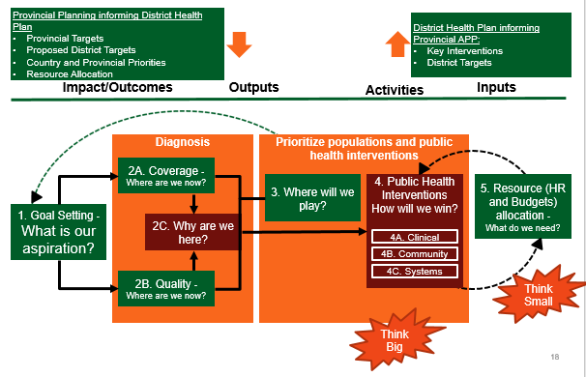

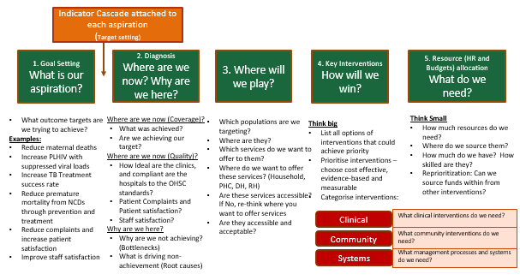

The compilation of the District Health Plan becomes secondary to the process of planning (or critical thinking) because it requires District Management Team to collectively agree (and document) the challenges and interventions as they are being discussed. The District Health Plan template is therefore exclusively guided by the planning steps (reasoning and critical-thinking process). The core contents of District Health Plans are made efficient by requiring that Districts supply “answers” to the “questions” for the steps outlined above in the revised District Health Planning framework.

This consensus building (priority setting) process will encourage all the managers (and stakeholders) in the District to work towards the agreed interventions and improve outcomes.

## District Monitoring Framework

The District Management Team must routinely monitor progress by actions and their outcomes and use it as the basis to compile a quarterly progress report following a formal performance review and submit it to the Head of District Health Services at Provincial DoH. This report must feed into the Provincial Quarterly Performance Reviews, and reports. In return, the Provincial Head of District Health Service must compile a feedback report to the District to recognize good performance, and intervene on areas of poor performance.

In the same matter, the Sub-Districts and Local Managers should monitor their progress by tracking actions, and compiling a monthly report to District Manager. In return, the District Manager must compile a feedback report to the Sub-District manager to reward good performance, and offer support in areas of poor performance.

The monitoring process is therefore made comprehensive but also simplified. It requires monitoring inputs, activities, outputs in tandem with outcomes and impacts (comprehensive), through a series of questions that are to be answered by District Management Teams (simplified).

This method would help Districts to:

1. assess whether plans were implemented,
2. assess whether actions resulted in impact (negatively or positively),
3. adjust actions in light of results.

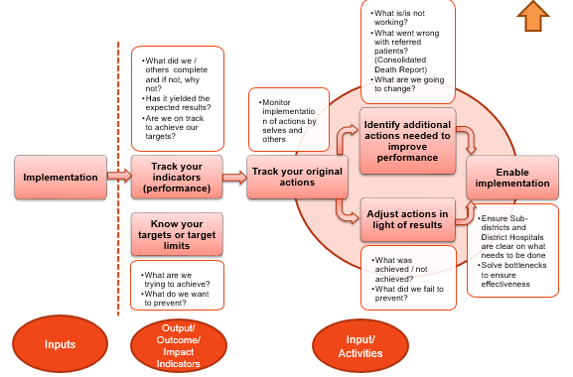

# WHO: roles and responsibilities of provincial office and District management

## Provincial co-ordination and support to Districts

The senior managers responsible for District Health System (DHS), Planning, Budgeting and M&E (by virtue of their responsibility) should play a leading role in providing support to Districts in their Planning, implementation and Monitoring efforts. The roles of the senior manager responsible for DHS, Planning, M&E were defined and approved by Tech NHC as part of the key recommendations from Technical working group on 11 August (refer to Annexure A).

* Head of **DHS** should co-ordinate all the activities targeted at Districts, and support District Managers to develop plans, track and support implementation to take care of provincial priorities and localized challenges. Furthermore, by implication, head of DHS must put a system in place to co-ordinate support to Districts and streamline communication between Provincial head office and District management teams.
* Head of **Planning and M&E** must develop processes and procedures with time lines that links the provincial and District planning, monitoring and reporting processes. Furthermore, these managers must support the planning and monitoring process by providing all the technical support (use of indicators, definitions, target setting, templates, etc) to enable implementation of the planning and monitoring process.
* Head of **Finance** must be involved to support Districts in identifying allocative inefficiencies’ and improve costing of their plans. This will assist finance managers to allocate funds to Districts based on need rather than historical spending.
* Head of **Information Management** advocate for better use of data, and encourage evidence based planning, by ensuring data is accessible, and offering their analytical skills. A comprehensive set of epidemiological health information with readily available data sources is compiled as evidence for District Management Teams to use in their planning process (Refer to Annexure C). The Provincial head of Information management should compile this with their District Information Offices of respective Districts, and make it available for the District planning process.

## District Planning, Monitoring and Response Forums

The District Management Team’s core functions include planning and monitoring. These are:

* Identification of client and stakeholder needs
* Identification of critical challenges and understand source of the challenges.
* Take decisions and set priorities proactively (at the start of the year), and reactively (during the year) in order to respond to undesired outcomes (which include avoidable deaths), and under achieved targets to learn and prevent recurrence, thus bringing down mortality
* Balance competing demands by taking decision on key District Actions which respond to key priorities, client and stakeholder needs and challenges.
* Allocate resources (time from personnel, goods and services and capital costs). Ensure that capacities are matched with planned Actions. Refine the Actions until the allocated resources meet the Actions.
* monitor and reflect on progress against plans,

A need exists for a forum which consist of relevant stakeholders from District and Sub-District Management Team(s) and with clear responsibilities for above functions which include setting priorities, developing plans, tracking implementation of plans, and reviewing plans.

There may be existing governance structures for this purpose, and this proposal is mindful of creating new structures. Existing structures can assume planning and monitoring responsibilities if the composition of the structure responds to above mentioned needs.

The functions and constitution of District Planning and Monitoring forums were defined and approved by Tech NHC as part of the key recommendations from Technical working group on 11 August. The NSPC and NDHSC proposed the following additions of HR Manager, provincial EMS manager, and District pharmacist to the approved composition of the forums.

The proposed composition (with functions) of the District and sub-district forums are provided in the next sections

### District Forums

|  |  |
| --- | --- |
| District Manager | Convener of the Planning and Monitoring forum.  Leadership, and guidance to overcome any obstacles with implementation |
| PHC Manager  Hospital Manager (responsible for all District Hospitals) | PHC Manager and Hospital Manager at District Office jointly presents the National / Provincial Priorities of the forthcoming year as well as performance of the District. |
| Finance Manager | Presents the results from the District Health Expenditure Review, and Budgets of the forthcoming year, and respond to all procurement needs. |
| HR Manager | Facilitate the recruitment prioritisation exercise for all vacant posts to ensure maximum impact for the available resources under compensation of employees |
| Sub-District Managers | Participate in all planning and performance review session to raise challenges experienced by clinics, propose interventions, and obtain commitment from District to address bottlenecks. |
| Planning and M&E Manager (District Information Officer or equivalent) | * Compile the comprehensive epidemiological health information, circulate and present at the district planning session. (refer to Annexure C) * Facilitate and support the planning process, and scribe district plans. * Routinely monitor implementation and meet reporting needs. * Provide feedback to sub-District managers on their data quality for the previous quarter |
| MCWH, TB/HIV, and NCD Programme Managers | * Outline the District performance for priority health programmes by doing presentations on performance of priority health programmes (refer to Annexure C for indicator list) * Define any programmatic needs for the next financial year |
| DCST members | * Advise on clinical governance and quality and measures taken in past quarter * Compile and present the consolidated death report (refer to Annexure A) |
| Quality Assurance co-ordinator | Presents the outcome of the latest self-assessment Ideal Clinic Dashboard at the District level, and Inspection reports from Office of Health Standards Compliance, and proposes interventions. |
| District pharmacist | Participate in all planning and performance review sessions to strengthen the supply chain system for all medicines and supplies. |
| EMS Manager | Understand district challenges, support and respond to all matters pertaining to patient transport |

### Sub-District forums

|  |  |
| --- | --- |
| Sub-District PHC Manager / Supervisor | Joint conveners of the forum.  Leadership, and guidance to overcome any obstacles with implementation  Presents budget (of the forthcoming month) and expenditure (for the past month) of the sub-District  (a) Presentation on synthesis of performance (as measured by key morbidity and mortality indicators and numbers and causes of deaths) and status of implementation of actions and whether implementation resulted in improvement, using a standardised report. Rank facilities for performance.  (b) Review and adjust actions  (c) health facilities present their monthly run charts.  (d) Sub-District Managers /Supervisors provide feedback on data quality to Facility managers |
| District Hospital CEO |
| Facility Supervisors and Facility Operational Managers | All facilities submit their monthly reports  Selected operational managers present the monthly run chart for PHC Dashboard and Hospital mortality indicators. |
| District Clinical Support Team: | Assist facilities with review of deaths and identification of avoidable factors and corrective action needed  Communicate recommendations from all facility visits to CEO / facility manager |
| Planning and M&E Manager (District Information Officer or equivalent) | Support the planning process, and scribe district plans.  Oversight to routinely monitor implementation and feedback to the stakeholders and meet reporting needs.  Provide feedback to Sub-District manager and health facilities on data quality |
| District Quality Assurance co-ordinator | Presents the outcome of the latest self-assessment Ideal Clinic Dashboard and formal OHSC inspections, and proposes interventions. |
| MCWH, TB/HIV, and NCD Programme Managers | Provide technical support, mentoring and Advice |

# WHEN: timeframes for the 2018/19 planning cycle

The planning and monitoring process promote the following principles:

1. Locate and secure the statutory budgeting, planning and monitoring time frames which are imposed by the PFMA. (steps 4a, 8 and 13)
2. Allow for top down (National Province and District) and bottom up (Sub District, District, Province and National) planning so that there is consensus on targets for key/priority indicators.
3. Allow for a process of rigorous interaction between Provincial head office and District Management Teams to ensure (a) support to Districts, and (b) consensus on key interventions, and targets.

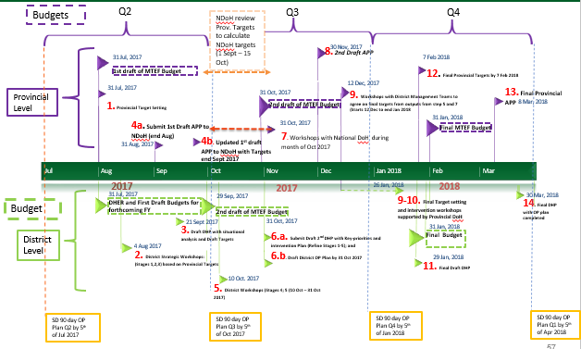

**Key:**

**1.** Provincial DoH with District Managers discuss Provincial Targets (Guided by Q1 Performance); Discuss high level interventions (strategies to attain targets); (during August 2017)

**2.** Workshops in Districts to start Planning discussions for next FY: Complete Goal Setting; and Diagnosis (refer to Steps 1, 2A, 2B, and 2C, 3 from the planning framework defined above) (commence during Aug 2017 to 21 Sept 2017)

**3.** Districts complete their first Draft DHP (with situational analysis and draft targets) by 21 Sept 2017.

**4a**. Provincial DoH submit 1st Draft APP end August 2017 (as required by PFMA)

**4b.** Provincial DoH submit updated 1st Draft APP with proposed Provincial targets by end Sept 2017.

**5.** District level workshops to determine key priorities and Interventions to achieve Targets (Stages 4,5) proposed by Provincial Head Office Starts 10 October – 31 October 2017. (Refine targets if necessary).

**6.** **6a.** Submit Draft 2nd DHP with key priorities and intervention plan with targets submitted to Provincial Head Office by 31 October 2017. **6b.** Commence to draft District Operational Plan for 2018/19

**7.** National DoH will conduct workshops with Provincial DoHs to review proposed Provincial Targets (Month of October)

**8**. Provincial DoH to produce its 2nd Draft APP with near final targets, and key interventions sourced from DHPs and submit by end November 2017 as required by PFMA.

**9-10**. Provincial DoHs and Districts conduct workshops from beginning Dec 2017 to end Jan 2018 to finalize Provincial Targets and interventions based on outputs from workshops conducted at steps 5 and 7.

**11.** Districts finalize DHP compiled with refined targets and interventions, and submit to Province and NDoH (end Jan 2018)

**12.** Provincial DoH submit Final Provincial Targets (guided by DHPs and final budgets) to National DoH by 7 February 2018.

**13.** Provincial DoH table Final Provincial APP according to legislature (around 8 Mar 2017)

**14**. Final DHP and District Operational Plan completed by end Mar 2018, and signed copies sent to Director-General.

# Alignment between Provincial Annual Performance Plans, and District Health Plans

The alignment of the format and process for the development of the District Health Plans with that of the Provincial Annual Performance Plans (APPs) had been identified through many fora and structures. The process outlined in section 7 integrates the timeframes by when various drafts of the Provincial APPs are required, and how they interact with the District Health Plans for 2018/19 year.

The National DoH has circulated the draft APP Format that for the MTEF period 2018/19-2020/21. It contains

1. guidance on the structure of the Provincial APPs,
2. set of indicators that all Provincial APPs must target, and set targets in alignment with District Targets
3. makes room for key District interventions in Part B of the plan for each budget programme. This provision is in form of a narrative to guard against audit risk

It is therefore believed that the revised district planning process will meaningfully inform planning and budgetary processes at provincial level. It will further create a mechanism for negotiation and lobbying between District and Province and in so doing developing a framework for decentralised planning and budgeting.

# Alignment between District Implementation Plan (DIP) process and District Planning Framework

The District Implementation Plan, adopted by the strategic health programmes (during the past 2 years) is now integrated into the District Operational Plan (DOP). The activities previously reflected in the DIP will now be addressed with the HAST district aspiration component of the DOP. This change will improve the integration and reduce duplication component of the DOP.

The Districts are expected to start drafting DOPs at the end of October for submission with their final DHPs at the end of March. The template for the District Operational Plan will be circulated in due course in order to allow Districts sufficient time to prepare for submission timelines.

The diagram below shows how the steps in the DIP Phase 3 process align to the new District Planning Process.

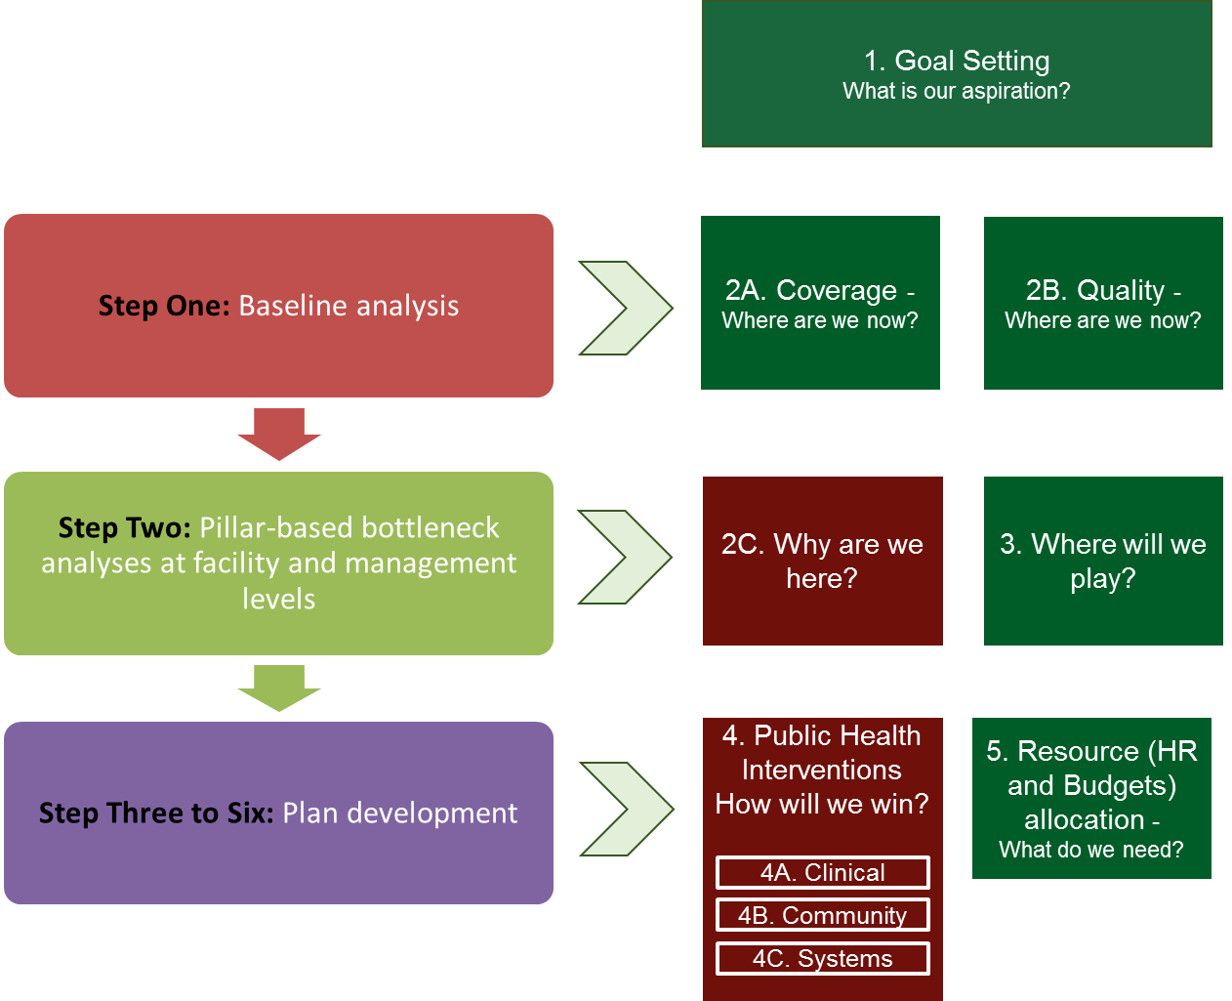

The DIP 2X4 Matrix used to determine bottlenecks is well-represented in the 10 Ideal Clinic Components. The mapping of these is shown below.

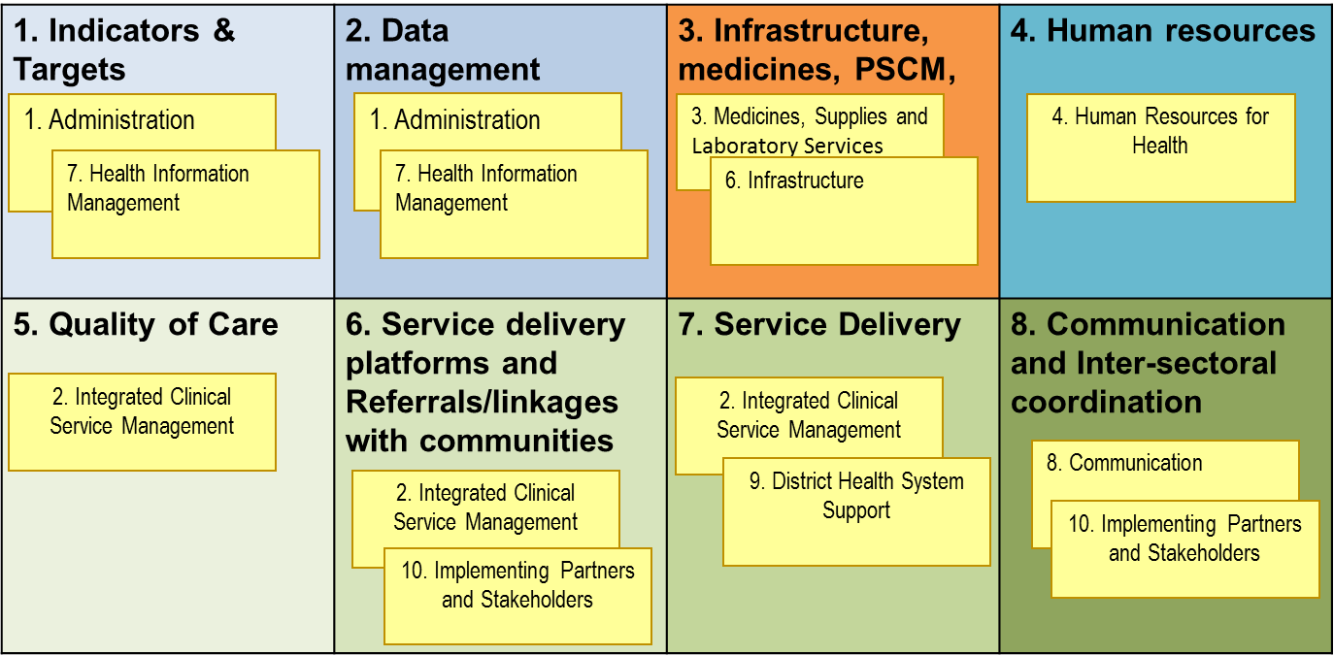

The Pillar-based planning approach has been adopted in the review of programmatic outcomes in the Population Prioritisation Matrix and Theory of Change indicators.

# PART B – DISTRICT HEALTH STRATEGIC PLANNING PROCESS



# Step 1 – What is our Aspiration?

## Process

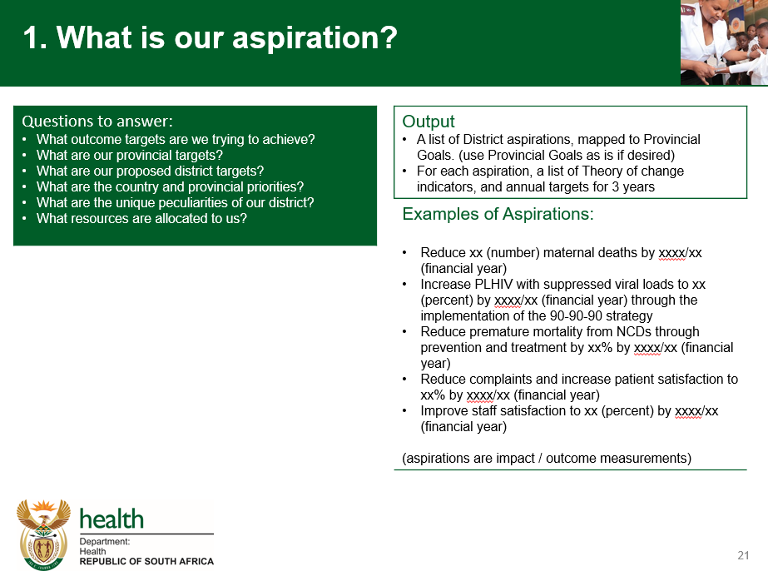

## Templates

Map District Aspirations to the corresponding Provincial Goal using the template below

|  |  |  |
| --- | --- | --- |
| **#** | **District Aspiration** | **Provincial Strategic Plan 2015-2020 Goal(s)** |
| **1** |  |  |
|  |
| **2** |  |  |
|  |  |

(one to many and many to one relationships are possible)

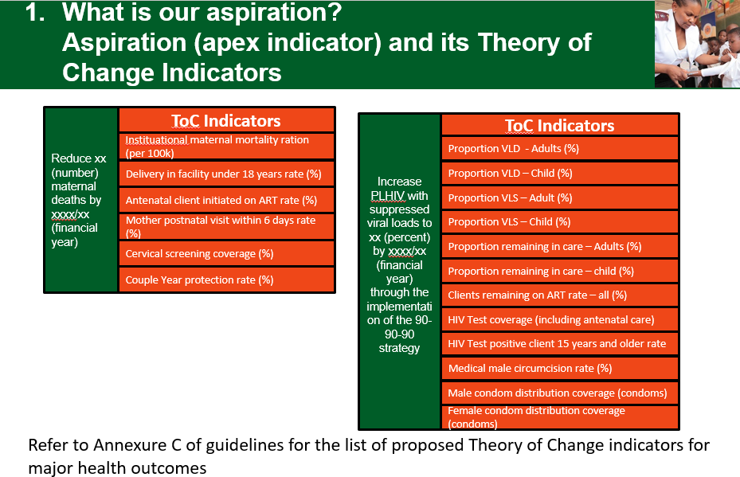

|  |  |  |  |  |  |  |
| --- | --- | --- | --- | --- | --- | --- |
| **District Aspiration** | **Indicator** | | **Baseline** | **Target**  **2018/19** | **Target**  **2019/20** | **Target**  **2020/21** |
|  | **(refer to Annex C for the indicator lists of HIV, TB, MCH and NCD programmes)** | |  |  |  |  |
|  | **Type** | **Name** |  |  |  |  |
| Impact |  |  |  |  |  |
| Numerator |  |  |  |  |
| Denominator |  |  |  |  |
| Outcome |  |  |  |  |  |
| Numerator |  |  |  |  |
| Denominator |  |  |  |  |
| Output |  |  |  |  |  |
| Numerator |  |  |  |  |
| Denominator |  |  |  |  |
|  | Impact |  |  |  |  |  |
| Numerator |  |  |  |  |
| Denominator |  |  |  |  |
| Outcome |  |  |  |  |  |
| Numerator |  |  |  |  |
| Denominator |  |  |  |  |
| Output |  |  |  |  |  |
| Numerator |  |  |  |  |
| Denominator |  |  |  |  |

# Step 2 – Diagnosis: Where are we now, and why are we here?

The diagnosis step is broken down into three steps outlined below.

# Step 2 A – Where are we now? (Outcome/Coverage Indicators)

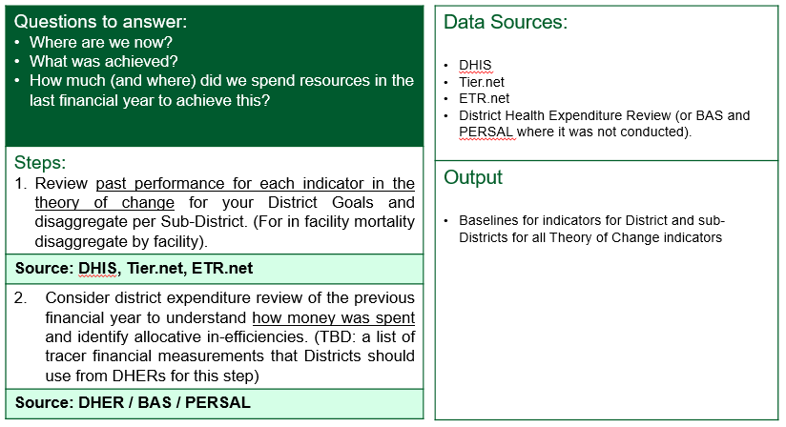

Theory of Change (Coverage) Indicators:

A comprehensive set of epidemiological health information with readily available data sources is compiled as a reference for District Management Teams to use in their planning process (Refer to **Annexure C**).

The District Information Officer (supported by provincial manager responsible for Health Information/data management) should produce this comprehensive set of epidemiological health information, and make use of it at the District Planning session.

(Refer to Annexure C for the list of indicators per strategic health programme)



Source: DHIS, Tier.net, ETR.net (District Health Barometer 2015/16, 2016/17),

# STEP 2 B – Where are we now? (Quality indicators)

When trying to understand where we are in terms of quality indicators, we assess ourselves against a set of standards that should be met within our facilities. It is by ensuring that all facilities meet this minimum standard, that the platform is geared towards high quality delivery of services.

## Process

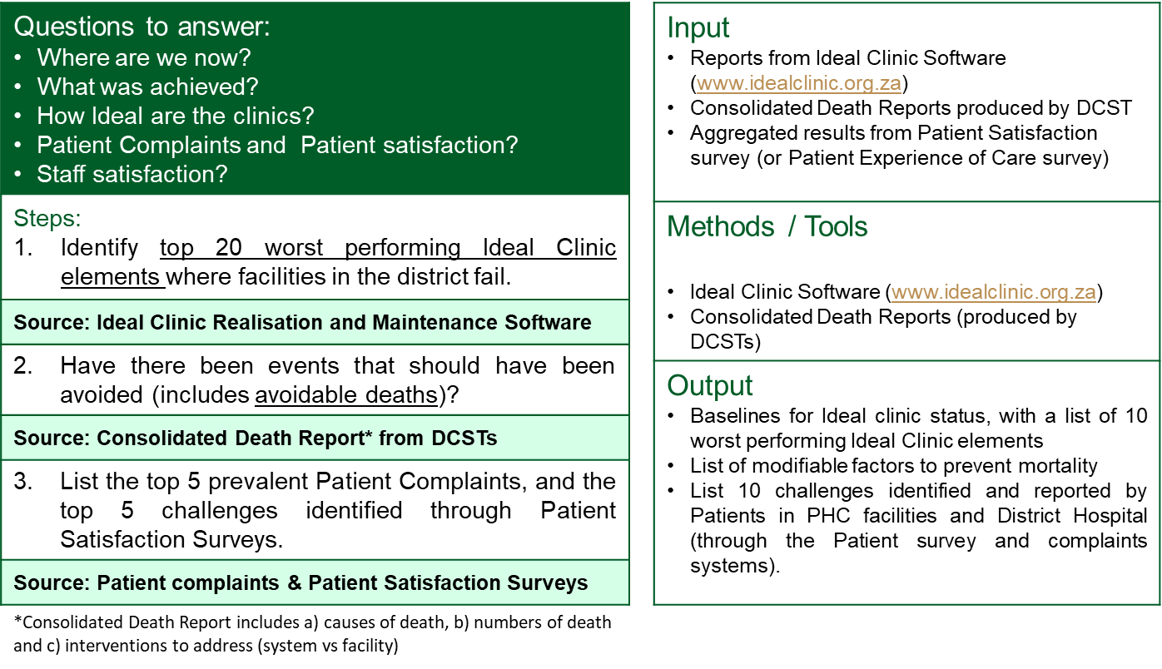

### Tool 1: PHC Facilities - Ideal Clinic software

#### Purpose:

Ideal Clinic Realisation and Maintenance (ICRM) Software is used in Ideal Clinic realisation to capture results from a standardised questionnaire which is translated into a dashboard (Ideal Clinic components, sub components and elements) used for tracking progress in PHCs over time. The ICRM software should be used in Districts to identify and list the top 20 worst performing Ideal Clinic elements (focussing on vital and essential elements) where facilities in the district fail; categorized into 10 components and 32 Sub-components as below:

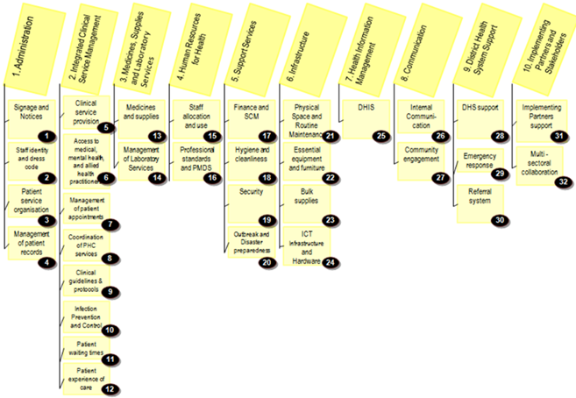

Download the Excel “Quality Improvement Plan report” from <http://idealclinic.org.za> for your District, and complete the following steps (1-7) to identify top 20 worst performing ideal clinic elements.

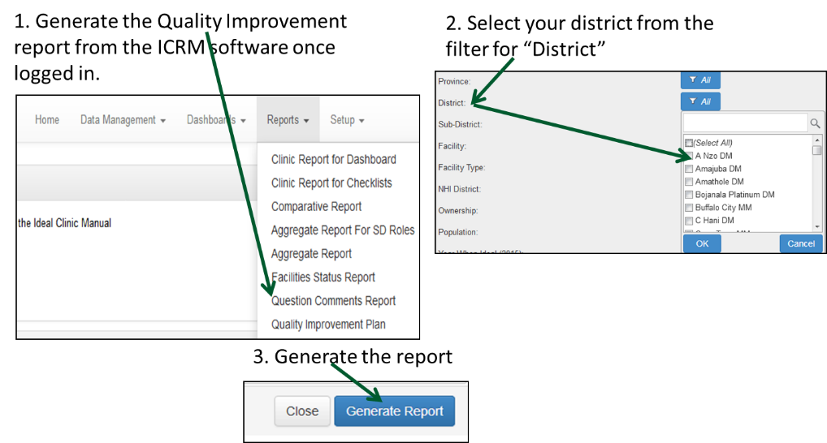

4. Open the report, highlight the rows and columns with data in it.

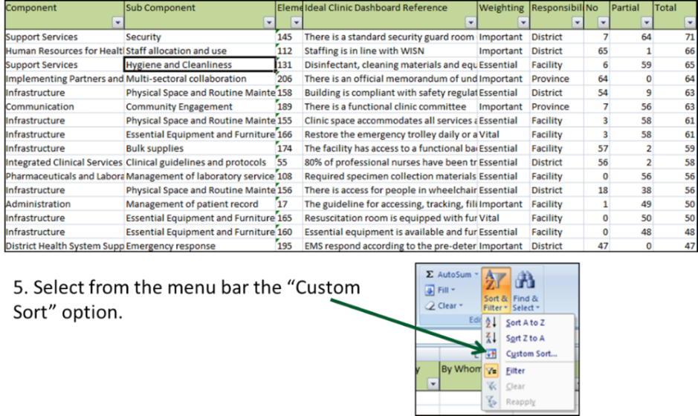

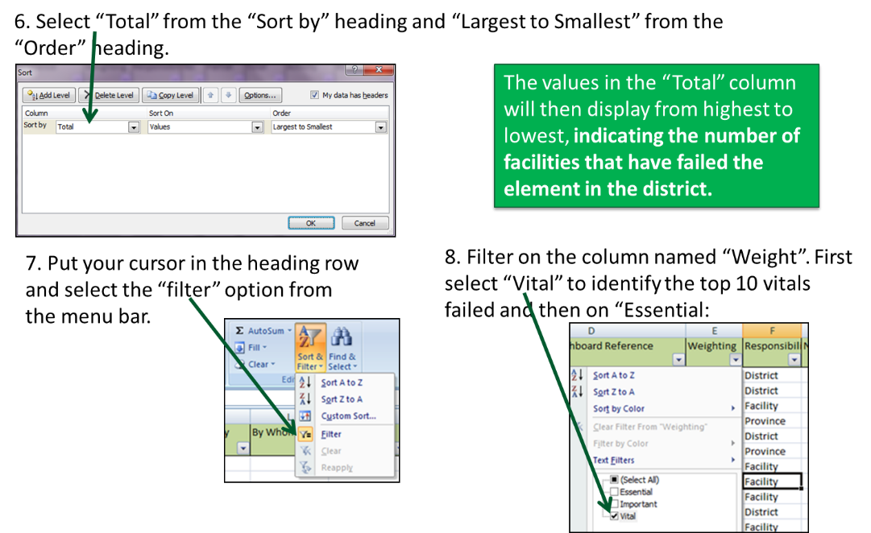

Once the 20 worst performing elements in the District have being identified through the ICRM software; the root causes of these challenges can be identified using the Five Whys or Problem Tree.

### Other challenges (Bottlenecks)

There are additional Bottlenecks that have resulted in poor health outcomes. These have been identified and categorise into the 10 components of the Ideal Clinic framework. This is to ensure that we leverage a consistent framework for understanding and categorising challenges within service delivery. The components are comprehensive and can be used in a similar way to the prongs of a fishbone analysis, the blocks in the 2X4 DIP matrix, the blocks in the 3X4 3-feet Approach, and the WHO Health System Strengthening building blocks. It is important to use consistent components in order to drive a common understanding and prioritisation.

The Ideal Clinic software will identify bottlenecks relating to standards not being met. However, the software does not currently allow us to identify other bottlenecks external to the health facility. These relate predominantly to district management, as well as demand for services from the population.

Additional questions (which have been utilised in DIP and 3-Feet approaches) to understand management and demand-side issues are considered to define questions, and align to components 2, 4, 8, and 10 of the Ideal Clinic framework as an expanded set to address system, and community aspects of planning.

It is useful to consider these bottlenecks across 4 prongs, namely Prevention, Case Identification, Treatment Initiation, and Treatment Success. For example, when considering morbidity and mortality in young girls, ask the questions below to understand whether these challenges are either restricting girls from accessing services or causing low demand for prevention services.

|  |  |
| --- | --- |
| Ideal Clinic Component | Questions to identify bottlenecks resulting in low demand for services |
| 2. Integrated Clinical Service Management | * Are your clinic operating hours optimal for clients who work or attend school? * Are services friendly to key and target populations e.g. drivers, sex workers, taxi drivers and young girls, MSM, migrants (including foreigners)? * Are services friendly to persons with disabilities like deaf, blind or physical disabilities? |
| 4. Human Resources for Health | * Does management conduct routine quality improvement orientated monthly meetings/data reviews? * Is there a process that management uses to identify best performing facilities and share best practices on a regularly basis? * Does the district management monitor implementation of plans and hold to account responsible persons? |
| 8. Communication | * Are there IEC materials and posters available? * Is communication material made available and media adapted for disabled community members: deaf, blind? * Have the facility targets been communicated to relevant stakeholders in the community e.g. community leaders, clinic committees, CBOs, NGOs and community at large? * Is the current performance regularly communicated in community forums and through standardised reports? * Are there mechanisms in place to communicate messages to the community? WBOTs? Local CBOs, CCGs? |
| 10. Implementing Partners and Stakeholders | * Are there any community beliefs and practices affecting uptake of services? What are these beliefs? * Are there client factors contributing to poor uptake of services e.g. alcohol and substance abuse, migration, working hours? * Do the CHWs, CCGs, WBOTS, School Health Teams etc., provide the required services at a household level, facility level respectively? * Does the district have a formal engagement with the private sector Health care providers (Clinics and Drs) to ensure services are provided and reported? * Is there evidence of scheduled campaigns linked to the facility? How often? * Do your facilities provide outreach services for key and target populations e.g. drivers, sex workers, taxi drivers and young girls, MSM, migrants (including foreigners)? |

### Tool 2: Hospitals - National Core Standards:

#### Purpose

The NCS is used in all hospitals to identify bottlenecks (challenges) according to the 7 Domains listed. District Managers should identify the top 20 elements under the 7 Domains in a district that fail.

Once the 20 worst performing elements in the District have being identified through the NCS; the root causes of these challenges can be identified using the Five Whys or Problem Tree method.

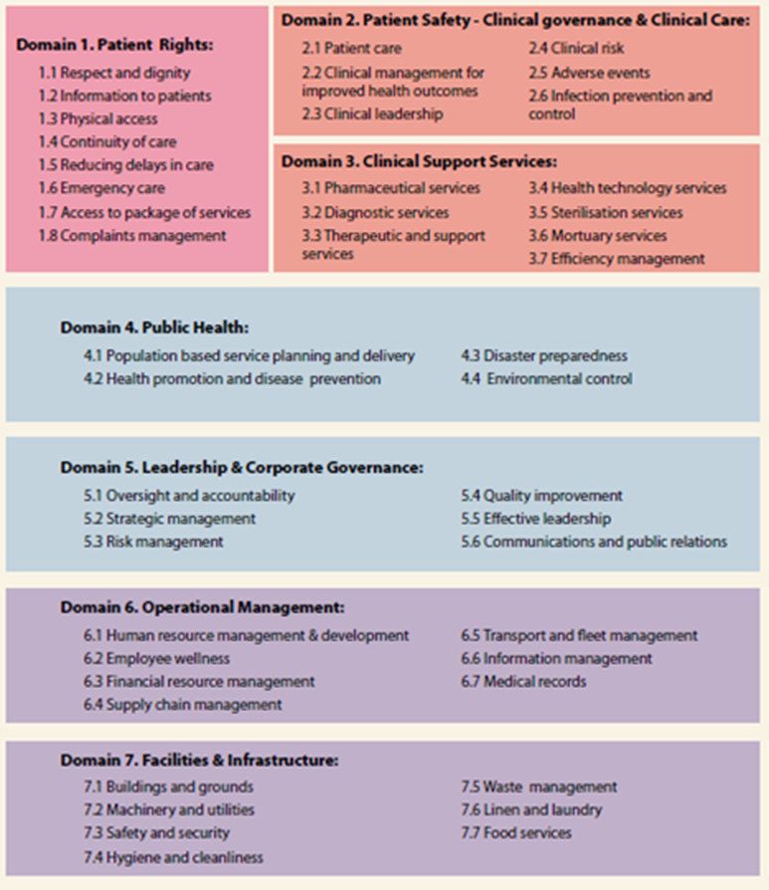

### Tool 3: Consolidated Death Report

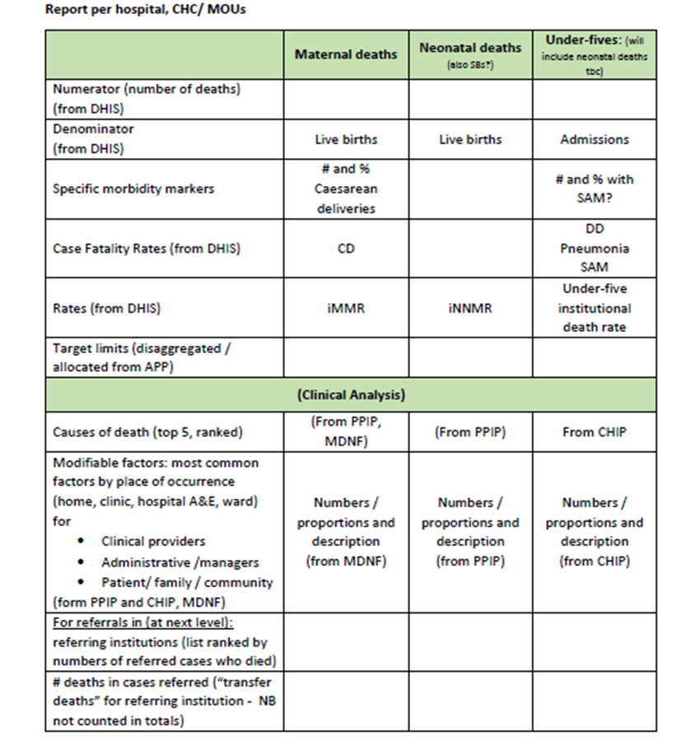

The consolidated death report is produced by the District Clinical Specialist Team (DCST) for the District (or Catchment area). The consolidated death report provides the following information for the most recent quarter:

1. Total numbers of in-facility maternal, neonatal and child deaths.
2. Lists the top 5 causes of deaths of (a) mothers, (b) newborns and (c) under-fives.
3. Lists the most common modifiable factors contributing to deaths
4. Identifies key interventions that need to be implemented in the District to reduce avoidable mortality (maternal, neonatal, and children under 5)

The Consolidate Death Reporting template is provided under Annexure B

### Tool 4: Patient Experience of Care Survey

The Patient Experience of Care Survey results can also be used to understand challenges to service delivery from a patient perspective.

# STEP 2C – Why are we here?

When trying to understand why we are not achieving the results we would like, we have to unpack the bottlenecks and the root causes of these. It is only by understanding underlying root causes that interventions can be defined to address the real problems. Root causes and the interventions that will address them fall into 3 main categories:

* Clinical
* Community
* Systems

**Clinical**

The Consolidated Death report not only provides the District with the number of deaths, but also provides root causes that contributed to these deaths. These root causes will largely be clinical, but will include Community and the Systems-based issues which are resulting in poor patient outcomes.

**Systems**

The challenges and root causes identified through the ICRM and NCS assessments will provide predominantly Systems-based issues to be addressed in order to improve performance.

**Community**

A lack of demand for services also contributes to poor performance. Irrespective of how good the quality of clinical care is, and how Ideal our clinics are, services cannot be provided unless there is demand for them. In understanding Community-based issues, outside of those identified through the Consolidated Death Report, ICRM and NCS assessments, a bottleneck analysis must be conducted using the additional questions listed above under Tool 4.

## Process

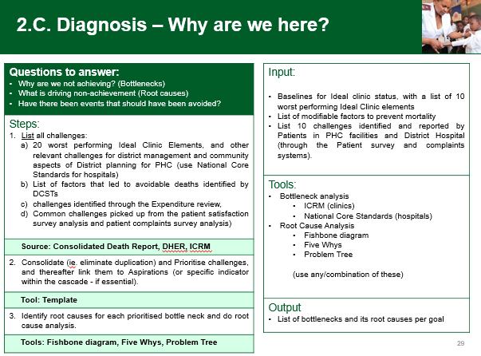

## Tools:

The bottlenecks identified from: 2B Where are we now? now need to further be unpacked in Step 2C – Why are we here?

The challenges (Bottlenecks) identified in step 2B will be further analysed to discover the “root causes” of each, using the Fishbone diagram (where applicable); Five Whys and Problem Tree.

### Tool 1: The Fishbone Analysis (Root cause analysis)

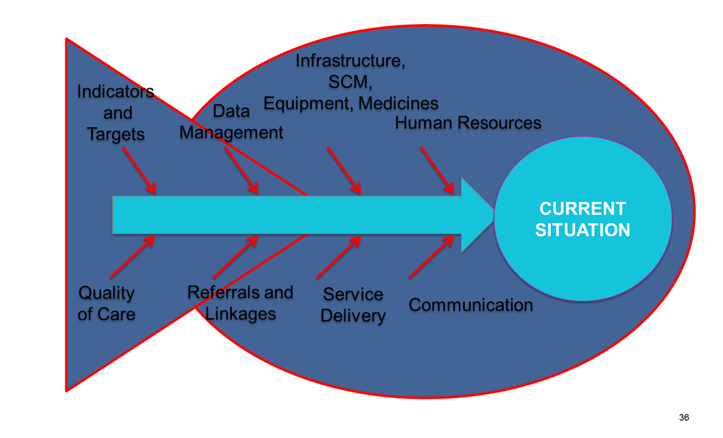

#### Purpose:

a. To identify the root causes of the challenges (Bottlenecks) identified.

#### Process:

Step 1: Write your challenge (bottleneck) in the Fishbone Diagram

* In the box on the far right of the diagram, write one challenge you have defined through applying Bottleneck analysis.

Step 2: Brainstorm possible causes for the identified bottleneck (s) and categorize the causes in Sub-component categories as per Ideal Clinic Framework nomenclature. Apply these categories to the fins of the fish diagram.

Step 3: Connect the categories to the central spine of the diagram (see example below)

* Draw arrows from each category to the central spine, as shown in the diagram

Step 4: Identify the root causes that are most responsible for the challenge

* For the categories which have the most significant impact on the challenge, probe deeper to understand the factors that sustain the current situation and keep you from moving to your desired result. Use the Five Whys technique to help you probe.
* Brainstorm and write the group’s ideas directly on the diagram
* Think about and select those causes that, if successfully addressed, will allow you to make significant progress toward the desired result. Circle these causes. In doing this, you are prioritizing root causes that need to be addressed in order to achieve impact.

#### Example of Fishbone Analysis:

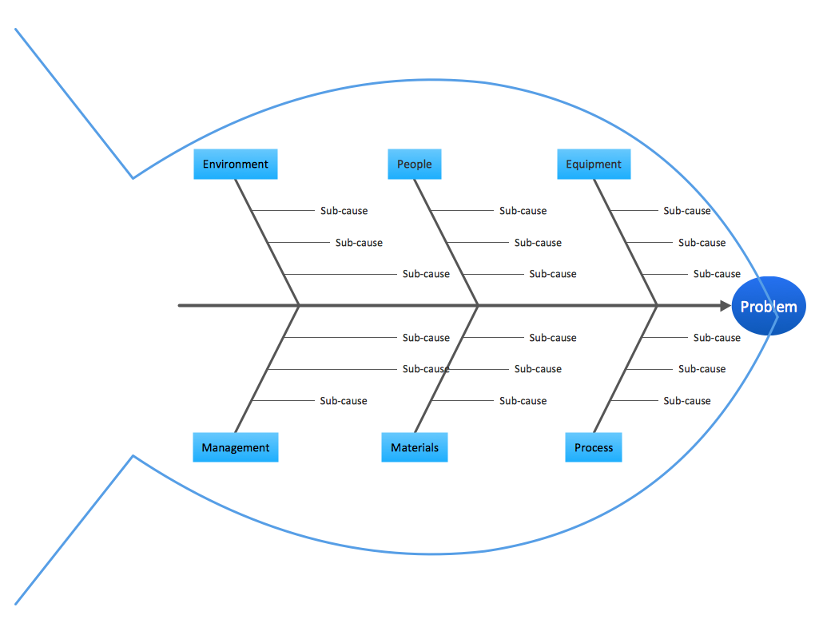

Categorise identified reasons for challenge according to Ideal Clinic Framework sub-components.

### The Five Whys Technique

#### Purpose

The 5 Whys is an iterative interrogative technique used to explore the cause-and-effect relationships underlying a particular problem.

#### Steps

The primary goal of the technique is to determine the root cause of a defect or problem by repeating the question "Why?" Each answer forms the basis of the next question.

Note: The method provides no hard and fast rules about what lines of questions to explore, or how long to continue the search for additional root causes. Thus, even when the method is closely followed, the outcome still depends upon the knowledge and persistence of the people involved.

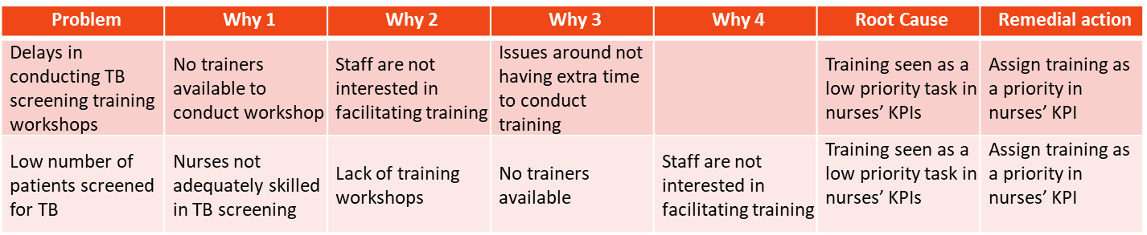

Benefits of the 5 Whys: Helps Identify the root cause of the problem; Determine the relationship between different root causes of a problem; One of the simplest tools; easy to complete without statistical analysis.

### Problem Tree

#### Purpose

A problem tree is a set of assumptions on root causes associated with the problem (challenge) and its *consequences* if not addressed.

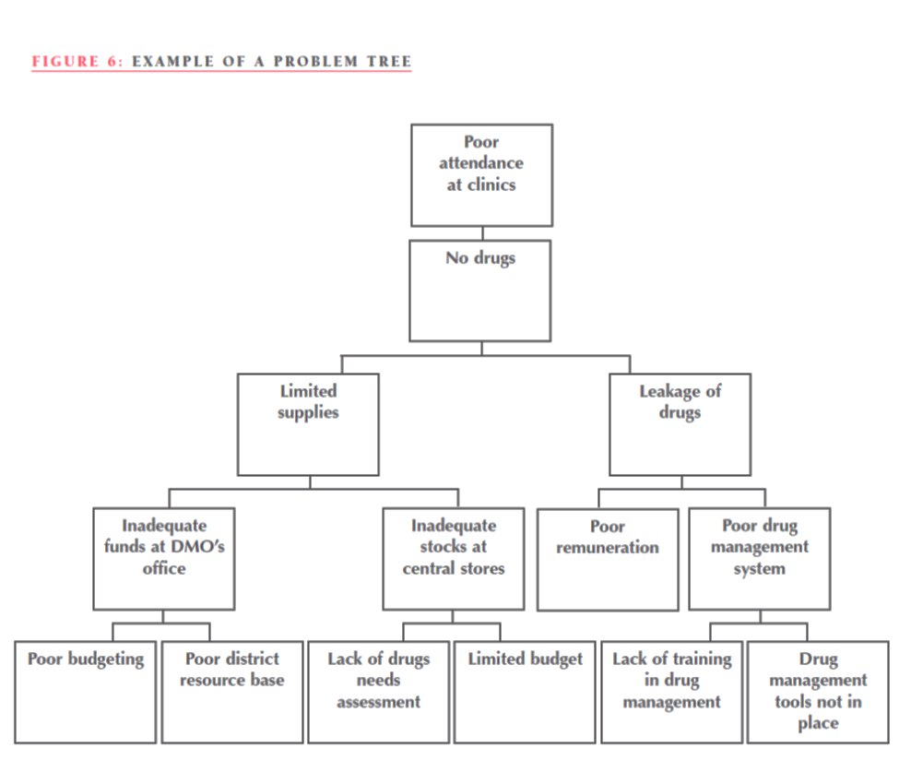

*Challenge*

*Consequence(s)*

#### Process:

Steps in problem tree construction[1]:

1. Write the problem statement on a large sheet of paper that is pinned to the wall. Members of the group will be given cards and pens.
2. Write down what you think are the main causes of the stated priority health problem. Write only one cause on each card and in as few words as possible.
3. For each cause, continue to ask yourself the question “BUT WHY?” and write down one answer per card.
4. Arrange the cards under the problem statement on the wall, thus creating a problem tree.
5. After reviewing some problems, you may realize that you wish to formulate the problem in a different way. For example, what appeared as a problem of lack of supplies for your ART programme may, when you analyse it, turn out to be a problem of communication.
6. After describing the *immediate* and *associated* causes of a problem you then describe the possible *consequences* of not addressing the problem. These are put above the problem and this completes the problem tree. E.g. “Poor attendance at clinics” in the figure above. You will realize that all the causes and consequences are described negatively.
7. The last step is to review the problem tree you have just constructed. Going through each of the causes you have identified, ask yourself “ Is this something we can change in the district?” We would like to focus on what is within the power of the district to improve, even if only in a small way.

### Template for Bottlenecks and Root-causes, linked to District Aspirations:

### Summarise Bottlenecks and Root-causes in the template below along with the corresponding aspiration:

|  |  |  |  |
| --- | --- | --- | --- |
| **Bottlenecks / Challenges** | **Root Causes** | **District**  **Aspiration #** | **District**  **Aspiration** |
| **1.** |  |  |  |
|  |  |  |
|  |  |  |
|  |  |  |
| **2.** |  |  |  |
|  |  |  |
|  |  |  |  |

# Step 3 Focus for Impact: Where will we play?

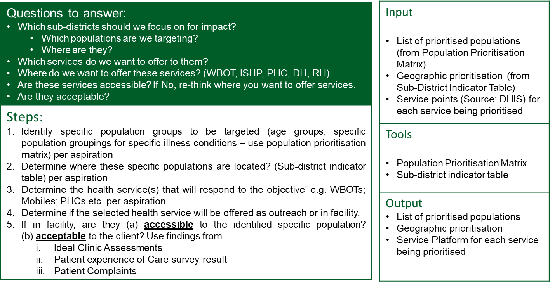

**Population Prioritisation Matrix   
(Life Course and Illness Condition)** 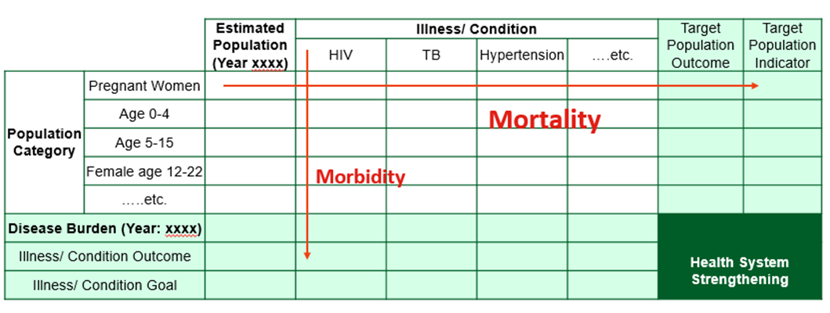

## Tools - Where will we Play?

### Tool 1. Causes of mortality

#### Purpose

The comprehensive District Health Barometer should be used to identify population categories in Districts/sub-districts with poor mortality outcomes as indicated in the Population Priority Matrix noted above (Horizontally). The District Health Barometer indicates the percentage of deaths per population category by broad cause and leading causes for a five year period per district, together with a detailed breakdown of deaths & causes.

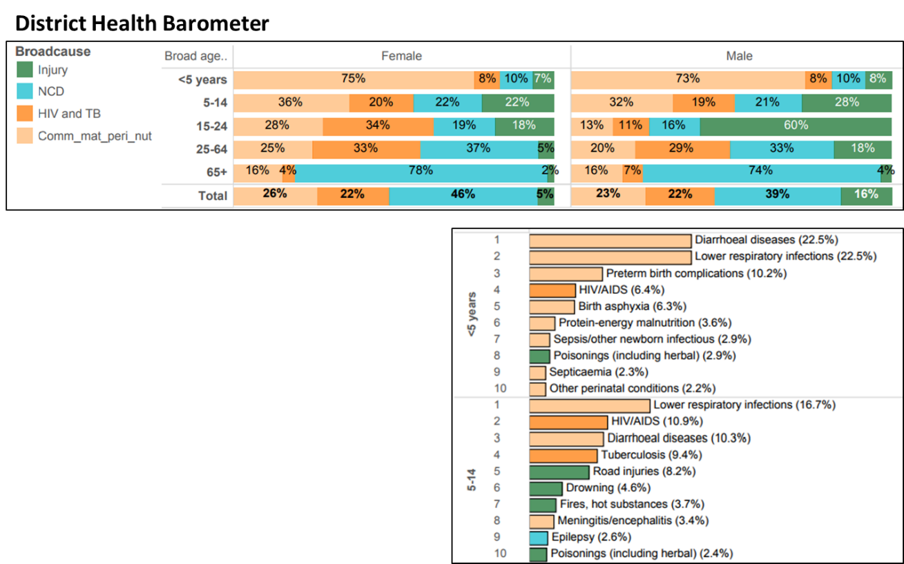

### Tool 2 – Sub-District Indicator Table

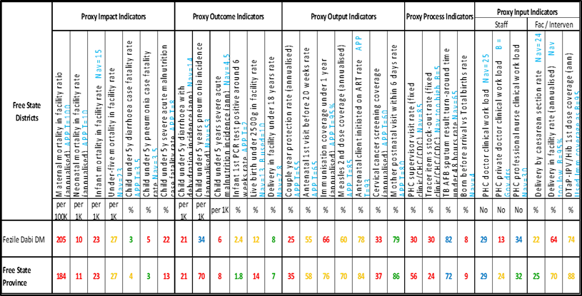

#### Purpose

The Sub-District Indicator Table lists Theory of Change indicators (Impact; Outcome, Output, Process and Input) indicators and their performance (value colourings).

The Indicator Table identify in which sub-district there are poor outcome performance. Districts should use the indicator table to identify the worse performing morbidity indicators per programme, those highlighted in red, to plan their target interventions.

Districts should focus in terms of targeting specific population groups for a **package of interventions** which address the leading causes of mortality or morbidity in that group; e.g. a high mortality rate in HIV + pregnant women, need collaborative intervention planning from both HIV & AIDS, STI & TB CONTROL (HAST) and MCWH&N programmes.

Step 4 –Focus for impact: How will we win?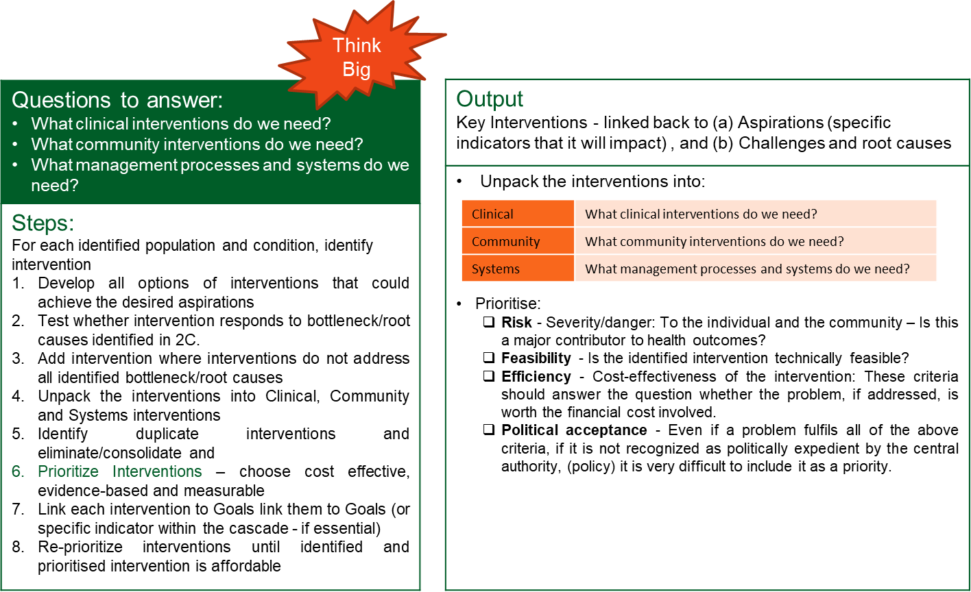

## Template: Where will we play and How will we win?

Once the target population has been identified through the above tools; and the interventions have been prioritized, the template (provided below) can be completed.

The intervention(s) should be linked back to District Aspirations (and specific indicators, where necessary, that it will impact, and challenges with their root-causes, earlier populated)

|  |  |  |  |  |  |  |  |  |  |
| --- | --- | --- | --- | --- | --- | --- | --- | --- | --- |
|  | **Population** | | **Geography** | | **Public Health Intervention** | | | **Costing** | |
| District Aspiration | Life Course Group | Key Population ** | (Sub-district)** | Ward ** | Key Intervention | Root Cause** | Service Delivery Platform* | Amount | Funding Source |
|  |  |  |  |  | 1. |  |  |  |  |
|  |  |  |  |  | 2. |  |  |  |  |
|  |  |
|  |  |

*WBOT, ISHP, PHC, DH, RH

** if applicable

Describe and unpack shortlisted Public Health Interventions into three dimensions:

|  |  |
| --- | --- |
| Public Health Intervention 1: | Description |
| Clinical |  |
| Community |  |
| Systems |  |

|  |  |
| --- | --- |
| Public Health Intervention 2: | Description |
| Clinical |  |
| Community |  |
| Systems |  |

# Step 5-Resource allocation: What do we need, How much?

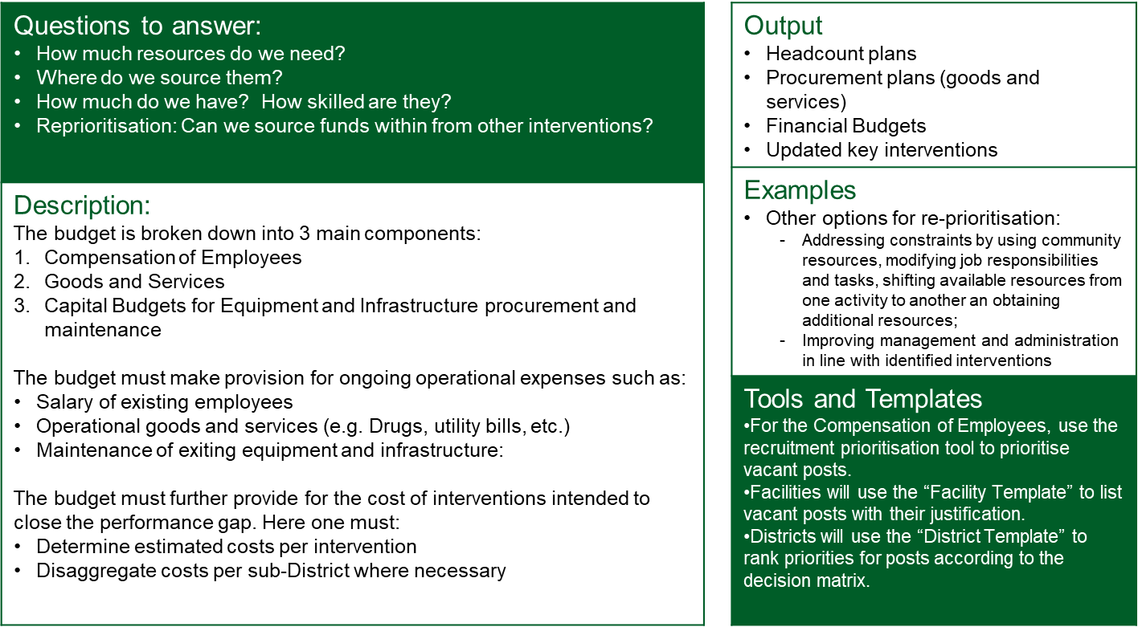

## Process – Recruitment prioritisation of Employees

* 1. Facilities will compile their recruitment needs for vacancies in order of priority, using the “Facility Template” of the recruitment prioritisation tool.
  2. A facility list with vacant posts and justification will be provided to Districts.
  3. Districts will review the lists submitted by their facilities using the “District Template” with the decision-making matrix to rank each post to identify most critical posts.

## Process – budgeting for goods and services

Preparing a budget implies the conversion of all activities and inputs, targets and support services into money terms:

1. The budget should include 3 main components:

* + Compensation of Employees (use the Recruitment Prioritisation Tool see below) to prioritise vacant posts.
  + Goods and Services
  + Capital Budgets for Equipment and Infrastructure procurement and maintenance.

2.. Make provision for ongoing operational expenses (Salary; Drugs, Utility bills, etc)

3. Cost interventions intended to close the performance gap (challenges identified):

* List all the activities and inputs required to solve the challenge that you have identified in the district
* List all the support services needed, such as transport, personnel, drugs, time, communications, Information Systems and training to enable the problem to be resolved.
* List the unit costs of all activities and calculate the total costs per intervention/per patient.
* Remember “No cost-Low cost”

## Tool: Recruitment Prioritisation

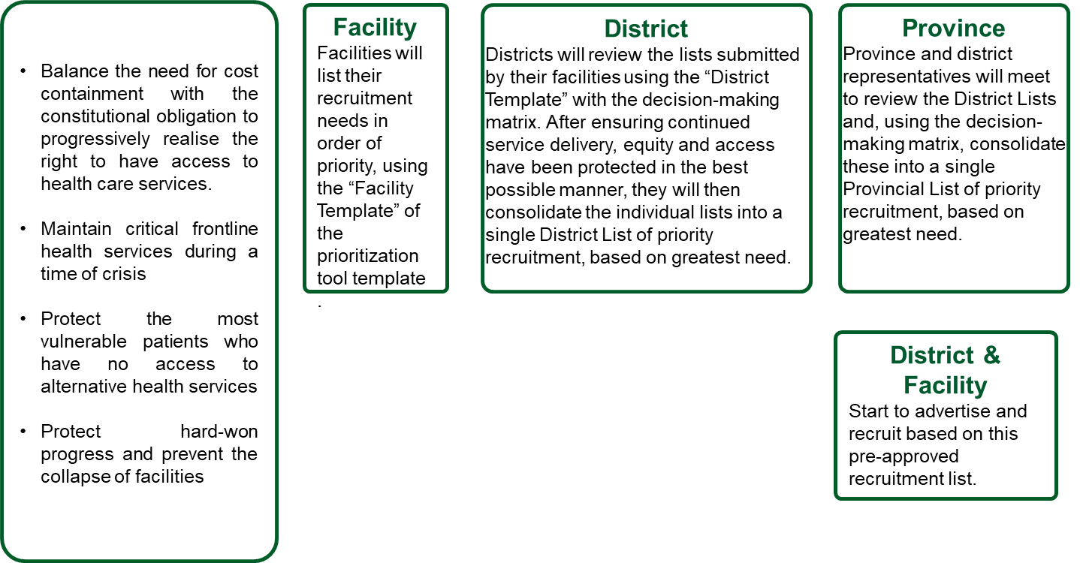

## Facility Template

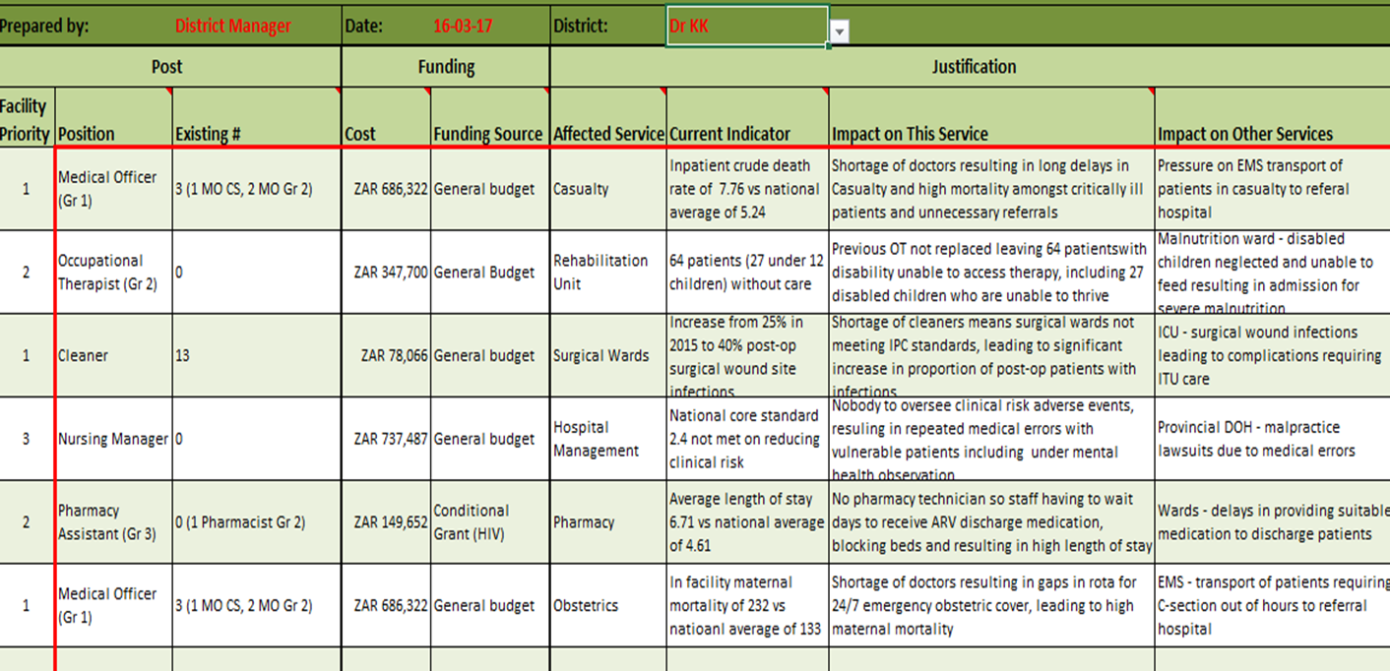

## District Template – Decision matrix to prioritise vacant posts

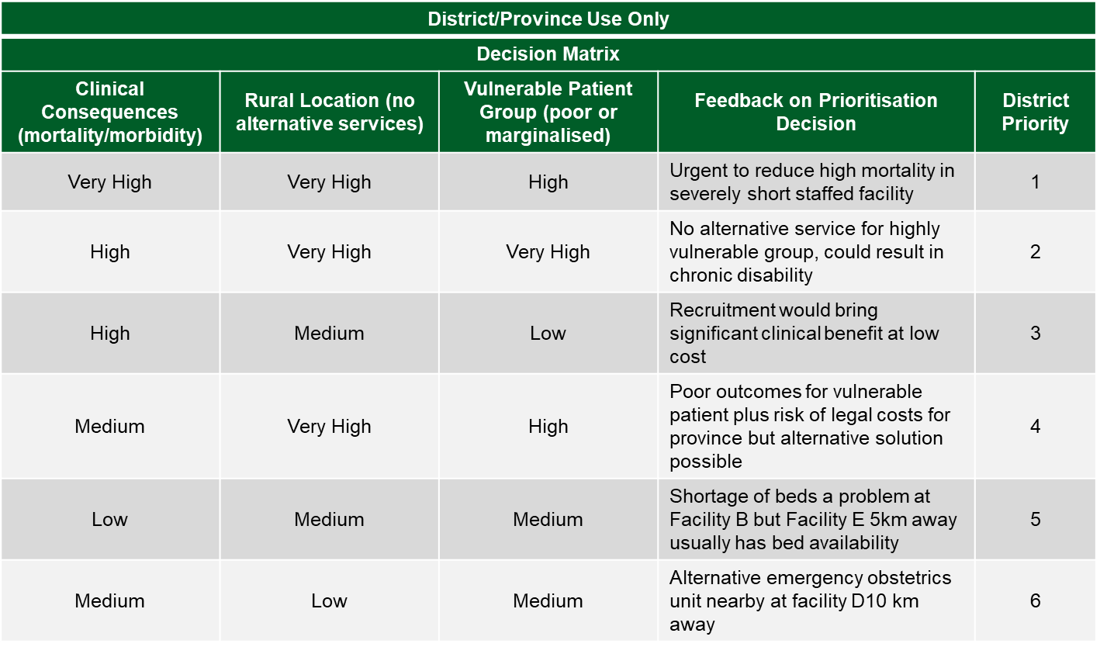

Example of a cost analysis table to cost interventions



PART C – DISTRICT HEALTH PLAN TEMPLATE 2018/19 – 2020/21

**Insert/provincial *district logo***

(DISTRICT NAME)

DISTRICT HEALTH PLAN

2018/19 - 2020/21

(PROVINCE NAME)

## EXECUTIVE SUMMARY BY THE DISTRICT MANAGER

The District Manager should provide a statement that provides an overview of the undertakings by the District to achieve district aspirations, and Provincial goals culminating into improved health outcomes. The executive summary must offer strategic direction of the District, that includes outlining the main challenges and interventions to achive district aspirations. The District Manager hereby also commits to ensuring successful implementation and monitoring of the plan.

## ACKNOWLEDGEMENTS

List the members of the District Management Team (that formed the District Planning and Monitoring Forum), and insert a paragraph to acknowledge their contribution to developing the District Health Plan.

## OFFICIAL SIGN OFF

It is hereby certified that this District Health Plan:

* Was developed by the district management team of **[Name of the District]** with the technical support from the district health services and the strategic planning Units at the Provincial head office.
* Was prepared in line with the current Strategic Plan and Annual Performance Plan of the **[Name of the Province]** Department of Health.

**___________________________ _______________**

**Name: District Manager Signature**

**Date: ____________________**

**____________________________ ______________**

**Name: Provincial Manager Responsible for DHS Signature**

**Date: _____________________**

**___________________________ ________________**

**Name: Accounting Officer (HOD) Signature**

**Date: _____________________**

## EPIDEMIOLOGICAL PROFILE

The District planning process required District Information Officer compile comprehensive epidemiological health information of the District (as per Annexure C) before the district planning workshop and make it available to the District Management Team to define aspirations, and identify key interventions.

Provide the following sections of the comprehensive epidemiological health information for the District, as a minimum:

* District Map with Population distribution, sub district boundaries, and health facility locations
* Social Determinants of Health
* Causes of Mortality
* Provide baseline data for all Theory of Change (Impact, Outcome, Output) Indicators for Maternal and Womens Health, Child Health, HIV and TB, by sub-District and for the District.
* (any other relevant information)

(refer to Annexure C for the templates for the above mentioned).

## SERVICE DELIVERY PLATFORM AND MANAGEMENT

The District planning process required District Information Officer compile comprehensive epidemiological health information of the District before the district planning workshop and make it available to the District Management Team to define aspirations, and identify key interventions.

Provide the following sections of the comprehensive epidemiological health information for the District (as outlined in Annexure C) is required as a minimum:

* Number of facilities per sub-district
* Human Resources for Health (filled posts)
* Management and efficiency indicators for the service delivery platform

(refer to Annexure C for the templates for the above mentioned).

## QUALITY OF CARE

* Top 20 worst performing ideal clinic elements in PHC facilities as at [date]
* Top 20 worst performance National Core Standards in District Hospitals as at [date]
* Top 5 challenges reported by patients in patient surveys, and patient complaints.

(refer to PART B – Step 2B for further guidance)

## ORGANISATIONAL STRUCTURE OF THE DISTRICT MANAGEMENT TEAM

|  |
| --- |
| (Insert District Management Team Organogram) |

## DISTRICT HEALTH EXPENDITURE

|  |  |  |  |  |  |  |  |  |
| --- | --- | --- | --- | --- | --- | --- | --- | --- |
| **DISTRICT SUMMARY** | | | | | | | | |
| **Sub-Programme** | | | **Budget: Adjusted Appropriation** | | | | | | **Expenditure** | | | | | **TOTAL** | |  |
| **Province** | | **Transfer to LG \*** | **LG Own** | **Province** | | | **Transfer to LG** | | **LG Own** | | **Budget** | **Expendi**  **ture** | **% Overspent (Underspent)** |
| 2.1 | District Management |  | |  | |  | |  | | |  | |  |  |  |  |
| 2.2 | Clinics |  | |  | |  | |  | | |  | |  |  |  |  |
| 2.3 | Community Health Centres |  | |  | |  | |  | | |  | |  |  |  |  |
| 2.4 | Community Services (incl. PAH) |  | |  | |  | |  | | |  | |  |  |  |  |
| 2.5 | Other Community Services |  | |  | |  | |  | | |  | |  |  |  |  |
| 2.6 | HIV/AIDS |  | |  | |  | |  | | |  | |  |  |  |  |
| 2.7 | Nutrition |  | |  | |  | |  | | |  | |  |  |  |  |
| 2.9 | District Hospitals |  | |  | |  | |  | | |  | |  |  |  |  |
| 2.12 | Other Donor Funding |  | |  | |  | |  | | |  | |  |  |  |  |
| TOTAL DISTRICT | | |  | |  |  |  | | |  | |  | |  |  |  |

Source: District Health Expenditure Review (2016/17) or BAS

*LG - Local Government

## DISTRICT ASPIRATIONS AND INDICATOR TARGETS

List the District aspirations, and map to the Provincial DoH Strategic Plan 2015-2020 goals.

|  |  |  |
| --- | --- | --- |
| **#** | **District Aspiration** | **Provincial Strategic Plan 2015-2020 Goal(s)** |
| **1** |  |  |
|  |
| **2** |  |  |
|  |  |

The following table should contain targets for all Theory of Change (impact, outcome and output) indicators for all District aspirations, to reach health outcomes. (Annexure C provides Theory of change indicators for Women and Maternal Health, Child Health, HIV and TB health outcomes)

|  |  |  |  |  |  |  |
| --- | --- | --- | --- | --- | --- | --- |
| **District Aspiration** | **Indicator** | | **Baseline** | **Target**  **2018/19** | **Target**  **2019/20** | **Target**  **2020/21** |
|  | **(refer to Annex C for the proposed indicator names for health outcomes/programmes)** | |  |  |  |  |
|  | **Type** | **Name** |  |  |  |  |
| Impact |  |  |  |  |  |
| Numerator |  |  |  |  |
| Denominator |  |  |  |  |
| Outcome |  |  |  |  |  |
| Numerator |  |  |  |  |
| Denominator |  |  |  |  |
| Output |  |  |  |  |  |
| Numerator |  |  |  |  |
| Denominator |  |  |  |  |
|  | Impact |  |  |  |  |  |
| Numerator |  |  |  |  |
| Denominator |  |  |  |  |
| Outcome |  |  |  |  |  |
| Numerator |  |  |  |  |
| Denominator |  |  |  |  |
| Output |  |  |  |  |  |
| Numerator |  |  |  |  |
| Denominator |  |  |  |  |

(refer to PART B: STEP 1 on guidance)

## BOTTLENECKS AND ROOT CAUSES

Summarise Bottlenecks and Root-causes in the template below along with the corresponding aspiration:

|  |  |  |  |
| --- | --- | --- | --- |
| **Bottlenecks / Challenges** | **Root Causes** | **District**  **Aspiration #** | **District**  **Aspiration** |
| **1.** |  |  |  |
|  |  |  |
|  |  |  |
|  |  |  |
| **2.** |  |  |  |
|  |  |  |
|  |  |  |  |

(Refer to PART B: STEP 2C for further guidance)

## KEY INTERVENTIONS

|  |  |  |  |  |  |  |  |  |  |
| --- | --- | --- | --- | --- | --- | --- | --- | --- | --- |
|  | **Population** | | **Geography** | | **Public Health Intervention** | | | **Costing** | |
| District Aspiration # | Life Course Group | Key Population ** | (Sub-district)** | Ward ** | Key Intervention | Root Cause** | Service Delivery Platform* | Amount | Funding Source |
|  |  |  |  |  | 1. |  |  |  |  |
|  |  |
|  |  |
|  |  |  |  |  | 2. |  |  |  |  |
|  |  |
|  |  |

*WBOT, ISHP, PHC, DH, RH

** if applicable

(refer to PART B: STEP 3 and 4 for further guidance)

Describe and unpack shortlisted Public Health Interventions into three dimensions:

|  |  |
| --- | --- |
| Public Health Intervention 1: | Description |
| Clinical |  |
| Community |  |
| Systems |  |

|  |  |
| --- | --- |
| Public Health Intervention 2: | Description |
| Clinical |  |
| Community |  |
| Systems |  |

# ANNEXURE A: Targets for Sustainable Development Goal 3 – “Good Health and Well-Being”

The SDGs, and the broader sustainability agenda, go much further than the MDGs, addressing the root causes of poverty and the universal need for development that works for all people.

1. By 2030, reduce the **global maternal mortality ratio** to less than **70 per 100,000** live births
2. By 2030, end preventable deaths of newborns and children under 5 years of age, with all countries aiming to reduce **neonatal mortality to 12 per 1,000** live births and **under-5 mortality to 25 per 1,000** live births
3. By 2030, **end the epidemics of AIDS, tuberculosis, malaria** and **neglected tropical diseases** and **combat hepatitis**, **water-borne diseases** and other **communicable diseases**
4. By 2030, **reduce by one third premature mortality from non-communicable diseases** through prevention and treatment and promote mental health and well-being
5. Strengthen the **prevention and treatment of substance abuse**, including narcotic drug abuse and harmful use of alcohol
6. By 2020, **halve the number of global deaths and injuries** from road **traffic accidents**
7. By 2030, ensure **universal access to sexual and reproductive health-care services**, including for family planning, information and education, and the integration of reproductive health into national strategies and programmes
8. **Achieve universal health coverage**, including financial risk protection, access to quality essential health-care services and access to safe, effective, quality and affordable essential medicines and vaccines for all
9. By 2030, substantially **reduce the number of deaths and illnesses** from **hazardous chemicals and air, water and soil pollution and contamination**
10. **Strengthen the implementation** of the World Health Organization **Framework Convention on Tobacco Control** in all countries, as appropriate
11. Support the research and development of vaccines and medicines for the communicable and non-communicable diseases that primarily affect developing countries, provide access to affordable essential medicines and vaccines, in accordance with the Doha Declaration on the TRIPS Agreement and Public Health, which affirms the right of developing countries to use to the full the provisions in the Agreement on Trade Related Aspects of Intellectual Property Rights regarding flexibilities to protect public health, and, in particular, provide access to medicines for all
12. Substantially increase health financing and the recruitment, development, training and retention of the health workforce in developing countries, especially in least developed countries and small island developing States.
13. Strengthen the capacity of all countries, in particular developing countries, for early warning, risk reduction and management of national and global health risks pertains to the health sector

ANNEXURE B: Consolidated Death Report Template for Maternal, Neonatal / Perinatal and Child Mortality (Example)

The reporting, analysis of and response to death events is already being implemented in different provinces or districts using different approaches; this proposal seeks to synthesise and integrate these approaches in the light of the importance of reducing mortality in key target groups. Inputs on the Standard Operating Procedure and this proposal have been requested from key expert groups as well as from provinces for its further refinement; the intention is to test the process during the coming year.

The templates that follow are examples; the actual report would be developed or adapted by the province (or district) in accordance with the following principles:

1. Reports compiled in accordance with the requirements of the national Standard Operating Procedure or SOP (distributed to HODs in June as a draft for testing and comment) and reflecting the use of a single source of data (i.e. clinical data, where relevant, must be sourced from or the same as DHIS data)
2. Compiled by a team / individual with clinical knowledge (DCST or clinical manager, depending on level)
3. Based on reports received from individual facilities:
   1. District hospitals
   2. PHC facilities if a death in one of the target groups has occurred there
   3. Referral hospitals (regional, sometime tertiary) which are the referral hospitals for that district (in relation to patients referred from the district)
4. Preferably monthly, could be quarterly in smaller districts
5. Covers all 3 key target groups (integrating the information where possible)
6. Reflects outcomes (mortality) and quality (modifiable factors) as components of a diagnosis
7. Captures information along the continuum of care or referral system / catchment area (place of delivery) and evidence-based practice
8. Includes a component on prioritised actions and roles (responsive action planning) to ensure correct practice in the future, with monitoring of actions and their impact

Examples of proposed templates for recording, reporting, review and response to deaths

1. Report per hospital / CHC
2. Aggregated report for district / catchment area: Maternal deaths
3. Aggregated report for district / catchment area: Neonatal and Perinatal deaths (may be integrated with B above)
4. Aggregated report for district / catchment area: Under-five deaths

The references are to different sections / steps of the revised District Health Planning guidelines, produced to guide the development of the District Health Plan (DHP), and in accordance with the guidelines for the Annual Performance Plan (APP)

1. **Report per hospital, CHC/ MOU**

**Step1 & Step 2 A and B: Targets, Diagnosis: outcomes, quality**

|  |  |  |  |  |  |
| --- | --- | --- | --- | --- | --- |
|  | **Maternal deaths** | **Neonatal deaths** | **Stillbirths** | **Under-fives**: (will include neonatal deaths) | **Assessment of performance, comments** |
| **From or linked to DHIS** | | | | | |
| Numerator (number of deaths) |  | Early / late / total |  |  |  |
| Cumulative to date |  |  |  |  |  |
| Target limits (disaggregated / allocated from APP) |  |  |  |  |  |
| Prediction – will exceed limit? |  |  |  |  |  |
| Denominator | Live births | Live births | Live births | Admissions |  |
| Rates / ratios | iMMR | iNNMR | SBR | Under-five institutional death rate |  |
| Specific morbidity markers | # and % Caesarean deliveries (CD) |  |  | # and % of deaths with SAM |  |
| # Deaths from specific diseases: |  |  |  | DD  Pneumonia  SAM |  |
| # admissions form specific diseases |  |  |  | DD  Pneumonia  SAM |  |
| Case Fatality Rates (CFR) or these diseases |  |  |  | DD  Pneumonia  SAM |  |
| **Clinical Analysis - from death review programmes** | | | | | |
| Causes of death (top 5, ranked) | (From PPIP, MDNF) | (From PPIP) | (From PPIP) | From CHIP |  |
| Specific conditions | CD CFR% |  |  |  |  |
| Specific categories |  | # deaths by weight category:  >2500g  1000- 2500g  <1000b | Gestational age >26 weeks |  |  |
| Modifiable factors: 1-2 most common factors showing place of occurrence (home, clinic, hospital A&E, ward) for   * Clinical providers * Administrative /managers * Patient/ family / community   (from PPIP and CHIP, MDNF) | Numbers / proportions and description  (from MDNF) | Numbers / proportions and description  (from PPIP) |  | Numbers / proportions and description  (from CHIP) |  |

**Steps 3 & 4 Prioritisation of interventions: place of delivery related to service delivery capacity (planned, actual)**

|  |  |  |  |  |  |
| --- | --- | --- | --- | --- | --- |
| **Referral system information from register (as appropriate for level of facility)** | | | | | |
| For referral hospitals (at next level):  # of deaths per referring hospital / institution (numbers of referred cases who died) |  |  |  |  |  |
| For referring institutions (from lower level):  # referrals who died (“transfer deaths”. NB not added twice in totals) |  |  |  |  |  |
| # deaths in transit (EMS) |  |  |  |  |  |

**Monitoring cycle: Responsive plan and implementation in response to review (modifiable factors and actions)**

* Standard approach for each target group using respective forms or software and Mortality & Morbidity discussion
* Report is never patient-linked
* Top 5 modifiable factors for each group, listed in the respective cell in the matrix
* Root cause analysis of modifiable factors to determine action and responsibility
* Recommendations made to hospital management and to district meeting

**For MATERNAL DEATH (obtained from Mortality & Morbidity discussion, information from Maternal Death Notification Form or MDNF)**

|  |  |  |  |  |  |  |
| --- | --- | --- | --- | --- | --- | --- |
| **Role/**  **Place of occurrence** | **Caregiver / patient** | | **Administrator / manager** | | **Clinical personnel / provider** | |
|  | **Factor** | **Action, responsibility** | **Factor** | **Action, responsibility** | **Factor** | **Action, responsibility** |
| Home |  |  |  |  |  |  |
|  |  |  |  |  |  |  |
| Clinic |  |  |  |  |  |  |
|  |  |  |  |  |  |  |
| Hospital: A&E, ward |  |  |  |  |  |  |
|  |  |  |  |  |  |  |

**For NEONATAL DEATH (obtained from Mortality & Morbidity discussion, information from PPIP)**

|  |  |  |  |  |  |  |
| --- | --- | --- | --- | --- | --- | --- |
| **Role/**  **Place of occurrence** | **Caregiver / patient** | | **Administrator / manager** | | **Clinical personnel / provider** | |
|  | **Factor** | **Action, responsibility** | **Factor** | **Action, responsibility** | **Factor** | **Action, responsibility** |
| Home |  |  |  |  |  |  |
|  |  |  |  |  |  |  |
| Clinic |  |  |  |  |  |  |
|  |  |  |  |  |  |  |
| Hospital: A&E, ward |  |  |  |  |  |  |
|  |  |  |  |  |  |  |

**For UNDER-FIVE DEATH (obtained from Mortality & Morbidity discussion, information from CHIP)**

|  |  |  |  |  |  |  |
| --- | --- | --- | --- | --- | --- | --- |
| **Role/**  **Place of occurrence** | **Caregiver / patient** | | **Administrator / manager** | | **Clinical personnel / provider** | |
|  | **Factor** | **Action, responsibility** | **Factor** | **Action, responsibility** | **Factor** | **Action, responsibility** |
| Home |  |  |  |  |  |  |
|  |  |  |  |  |  |  |
| Clinic |  |  |  |  |  |  |
|  |  |  |  |  |  |  |
| Hospital: A&E, ward |  |  |  |  |  |  |
|  |  |  |  |  |  |  |

**Monitoring of performance**

* Was modifiable factor identified in previous reports (6 months)? if so: *what action and responsibility was decided, *status done / not done. *If action not carried out, reason for this?
* Actions previously recommended for the hospital itself that have not been carried out
* Actions previously recommended to the District that have not been carried out

**Synthesis:** →Hospital on track / or concern

1. **Report for district / catchment area - Maternal deaths**

**Step 1 & Step 2 A and B: Targets, Diagnosis: outcomes, quality**

|  |  |  |  |  |  |  |  |
| --- | --- | --- | --- | --- | --- | --- | --- |
|  | **Referral hospital 1** | **Referral hospital 2** |  | **District hospital 1** | **District hospital 2** | **District hospital 3** | **CHC (if death)** |
|  | **(NAME)** | **(NAME)** |  | **(NAME)** | **(NAME)** | **(NAME)** | **(NAME)** |
| **From or linked to DHIS** | | | | | | | |
| Numerator (number of deaths) |  |  |  |  |  |  |  |
| Cumulative to date |  |  |  |  |  |  |  |
| Target limits (# - disaggregated / allocated from APP) |  |  |  |  |  |  |  |
| Denominator Live births  (from DHIS) |  |  |  |  |  |  |  |
| iMMR |  |  |  |  |  |  |  |
| Specific indicators: # and % Caesarean deliveries (CD) |  |  |  |  |  |  |  |
| **Clinical Analysis - from death review programmes** | | | | | | | |
| Causes of death (top 5, ranked) (From PPIP, MDNF) |  |  |  |  |  |  |  |
| CD Case Fatality Rates |  |  |  |  |  |  |  |
| Modifiable factors (from MDNF): most common factors by place of occurrence (home, clinic, hospital A&E, ward) for   * Clinical providers * Administrative /managers * Patient/ family / community   (from PPIP, MDNF) | (Numbers / proportions and description |  |  |  |  |  |  |

**Steps 3 & 4 Prioritisation of interventions: place of delivery related to service delivery capacity (planned, actual)**

|  |  |  |  |  |  |  |  |
| --- | --- | --- | --- | --- | --- | --- | --- |
| **Referral system analysis** | | | | | | | |
| For referral hospitals (at next level):  # of deaths per referring hospital / institution (numbers of referred cases who died) |  |  |  |  |  |  |  |
| For referring institutions (from lower level):  # referrals who died (“transfer deaths”. NB not added twice in totals) |  |  |  |  |  |  |  |
| # deaths in transit (EMS) |  |  |  |  |  |  |  |

**Monitoring cycle: Responsive plan and implementation in response to review (modifiable factors and actions)**

* Commonest modifiable factors listed
* Root cause analysis of modifiable factors to determine action and responsibility

|  |  |  |  |  |  |  |
| --- | --- | --- | --- | --- | --- | --- |
| **Role/**  **Place of occurrence** | **Caregiver / patient** | | **Administrator / manager** | | **Clinical personnel / provider** | |
|  | **Factor** | **Action, responsibility** | **Factor** | **Action, responsibility** | **Factor** | **Action, responsibility** |
| Home |  |  |  |  |  |  |
|  |  |  |  |  |  |  |
| Clinic |  |  |  |  |  |  |
|  |  |  |  |  |  |  |
| Hospital: A&E, ward |  |  |  |  |  |  |
|  |  |  |  |  |  |  |

**Monitoring of performance**

* Was modifiable factor identified in previous reports (6 months)? if so: *what action and responsibility was decided, *status done / not done. *If action not carried out, reason for this?
* Actions previously recommended for the hospital itself that have not been carried out
* Actions previously recommended to the District that have not been carried out

**Synthesis**: →Hospitals on track /Hospitals of concern and actions recommended

**C. Report for district / catchment area - Neonatal and Perinatal deaths**

**Step 1 & Step 2 A and B: Targets, Diagnosis: outcomes, quality (NB includes deaths in both Neonatal and Paediatric wards)**

|  |  |  |  |  |  |  |
| --- | --- | --- | --- | --- | --- | --- |
|  | **Referral hospital 1** | **Referral hospital 2** | **District hospital 1** | **District hospital 2** | **District hospital 3** | **CHC (if death)** |
|  | **(NAME)** | **(NAME)** | **(NAME)** | **(NAME)** | **(NAME)** | **(NAME)** |
| **From or linked to DHIS** | | | | | | |
| Numerator (number of **neonatal** deaths) |  |  |  |  |  |  |
| Of which early / late |  |  |  |  |  |  |
| Target limits neonatal deaths (# - allocated from APP) |  |  |  |  |  |  |
| # **Stillbirths** |  |  |  |  |  |  |
| Denominator Live births |  |  |  |  |  |  |
| iNNMR |  |  |  |  |  |  |
| iSBR |  |  |  |  |  |  |
| Specific indicators: |  |  |  |  |  |  |
| **Clinical Analysis - from death review programmes (**PPIP, CHIP) | | | | | | |
| Causes of death (top 5, ranked) (From PPIP, CHIP) |  |  |  |  |  |  |
| Weight categories: (# and %)  >2500g  1000-2500g  <1000g |  |  |  |  |  |  |
| Modifiable factors (from MDNF): most common factors by place of occurrence (home, clinic, hospital A&E, ward) for   * Clinical providers * Administrative /managers * Patient/ family / community   (from PPIP and CHIP) | Numbers / proportions and description | Numbers / proportions and description | Numbers / proportions and description |  |  |  |

**Steps 3 & 4 Prioritisation of interventions: place of delivery related to service delivery capacity**

|  |  |  |  |  |  |  |
| --- | --- | --- | --- | --- | --- | --- |
| **Referral system analysis** | | | |  |  |  |
| For referral hospitals (at next level):  # of deaths per referring hospital / institution (numbers of referred cases who died) |  |  |  |  |  |  |
| For referring institutions (from lower level):  # referrals who died (“transfer deaths”. NB not added twice in totals) |  |  |  |  |  |  |
| # deaths in transit |  |  |  |  |  |  |

**Monitoring cycle: Responsive plan and implementation in response to review (modifiable factors and actions)**

* Commonest modifiable factors listed
* Root cause analysis of modifiable factors to determine action and responsibility

|  |  |  |  |  |  |  |
| --- | --- | --- | --- | --- | --- | --- |
| **Role/**  **Place of occurrence** | **Caregiver / patient** | | **Administrator / manager** | | **Clinical personnel / provider** | |
|  | **Factor** | **Action, responsibility** | **Factor** | **Action, responsibility** | **Factor** | **Action, responsibility** |
| Home |  |  |  |  |  |  |
|  |  |  |  |  |  |  |
| Clinic |  |  |  |  |  |  |
|  |  |  |  |  |  |  |
| Hospital: A&E, ward |  |  |  |  |  |  |
|  |  |  |  |  |  |  |

**Monitoring of performance**

* Was modifiable factor identified in previous reports (6 months)? if so: *what action and responsibility was decided, *status done / not done. *If action not carried out, reason for this?
* Actions previously recommended for the hospital itself that have not been carried out
* Actions previously recommended to the District that have not been carried out

Synthesis: →Hospitals on track /Hospitals of concern and actions recommended

**D. Report for district / catchment area - Under-five deaths**

**Step 1 & Step 2 A and B: Targets, Diagnosis: outcomes, quality**

|  |  |  |  |  |  |  |
| --- | --- | --- | --- | --- | --- | --- |
|  | **Referral hospital 1** | **Referral hospital 2** | **District hospital 1** | **District hospital 2** | **District hospital 3** | **CHC (if death)** |
|  | **(NAME)** | **(NAME)** | **(NAME)** | **(NAME)** | **(NAME)** | **(NAME)** |
| **From or linked to DHIS** | | | | | | |
| Numerator (number of deaths) |  |  |  |  |  |  |
| Cumulative to date |  |  |  |  |  |  |
| Of which 29 days – 5 years (not neonatal) |  |  |  |  |  |  |
| Target limits (# - disaggregated / allocated from APP) |  |  |  |  |  |  |
| Under-five in-facility death rate |  |  |  |  |  |  |
| # and % of deaths with SAM |  |  |  |  |  |  |
| # Deaths from specific diseases:  Diarrhoea  Pneumonia  SAM |  |  |  |  |  |  |
| # admissions form specific diseases:  Diarrhoea  Pneumonia  SAM |  |  |  |  |  |  |
| Case Fatality Rates:  Diarrhoea  Pneumonia  SAM |  |  |  |  |  |  |
| **Clinical Analysis - from death review programmes** | | | | | | |
| Causes of death (top 5, ranked) (From CHIP) |  |  |  |  |  |  |
| #&% <1 year |  |  |  |  |  |  |
| Modifiable factors (from CHIP): most common factors by place of occurrence (home, clinic, hospital A&E, ward) for   * Clinical providers * Administrative /managers * Patient/ family / community | (Numbers / proportions and description |  |  |  |  |  |

**Steps 3 & 4 Prioritisation of interventions: place of delivery related to service delivery capacity**

|  |  |  |  |  |  |  |
| --- | --- | --- | --- | --- | --- | --- |
| **Referral system analysis** | | | | | | |
| For referral hospitals (at next level):  # of deaths per referring hospital / institution (numbers of referred cases who died) |  |  |  |  |  |  |
| For referring institutions (from lower level):  # referrals who died (“transfer deaths”. NB not added twice in totals) |  |  |  |  |  |  |
| # deaths in transit (EMS) |  |  |  |  |  |  |

**Monitoring cycle: Responsive plan and implementation in response to review (modifiable factors and actions)**

* Commonest modifiable factors listed
* Root cause analysis of modifiable factors to determine action and responsibility

|  |  |  |  |  |  |  |
| --- | --- | --- | --- | --- | --- | --- |
| **Role/**  **Place of occurrence** | **Caregiver / patient** | | **Administrator / manager** | | **Clinical personnel / provider** | |
|  | **Factor** | **Action, responsibility** | **Factor** | **Action, responsibility** | **Factor** | **Action, responsibility** |
| Home |  |  |  |  |  |  |
|  |  |  |  |  |  |  |
| Clinic |  |  |  |  |  |  |
|  |  |  |  |  |  |  |
| Hospital: A&E, ward |  |  |  |  |  |  |
|  |  |  |  |  |  |  |

**Monitoring of performance**

* Was modifiable factor identified in previous reports (6 months)? if so: *what action and responsibility was decided, *status done / not done. *If action not carried out, reason for this?
* Actions previously recommended for the hospital itself that have not been carried out
* Actions previously recommended to the District that have not been carried out

**Synthesis:** → Hospitals on track /Hospitals of concern and actions recommended

# Annexure C: Comprehensive Health Information to conduct situational analysis

This section proposes comprehensive epidemiological health information (with data sources) that is currently available to National and Provincial Department of Health and its District Management Teams. District Management Teams should use this data and information for strategic planning (identifying public health interventions, and planning for health services). The essential Theory of Change indicators for indicators for health programmes are provided and listed under their respective.

(The National DoH will develop district profiles with health information in this format for ease of reference and circulate by 8 September 2017)

**OR Tambo District Municipality**

OR Tambo District is the most populous of the six district municipalities in the Eastern Cape Province, with a population of 1 382 399 and a population density of 114.3 persons per km2. The district covers about 80% of what used to be marginalised homeland in the Transkei and incudes four health sub-districts: King Dalindyebo, Nyandeni, Mhlontlo and Qaukeni. The district falls into socio-economic Quintile 1, among the poorest districts, and has an estimated medical scheme coverage of 4.5%. It is one of 11 National Health Insurance (NHI) pilot districts.

**Social determinants of health**

|  |  |
| --- | --- |
| Unemployment rate |  |
| Youth unemployment rate (15-34 years) |  |
| No schooling |  |
| Matric |  |
| Higher education |  |
| Households |  |
| Female headed households |  |
| Formal dwellings |  |
| Flush toilet connected to sewerage |  |
| Weekly refuge removal |  |
| Piped water inside dwellings |  |
| Electricity for lighting |  |
| Blue drop water score |  |

Source: Stats SA (Local Government Handbook)

**Population distribution, sub-district boundaries and health facility locations**

**Population per selected category**

| Population category | 2016 | 2017 | 2018 | 2019 | 2020 |
| --- | --- | --- | --- | --- | --- |
| under 1 year |  |  |  |  |  |
| under 5 years |  |  |  |  |  |
| 05-09 years |  |  |  |  |  |
| 10-14 years |  |  |  |  |  |
| 15-19 years |  |  |  |  |  |
| 20-24 years |  |  |  |  |  |
| 25-29 years |  |  |  |  |  |
| 30-34 years |  |  |  |  |  |
| 35-39 years |  |  |  |  |  |
| 40-44 years |  |  |  |  |  |
| 45-49 years |  |  |  |  |  |
| 50-54 years |  |  |  |  |  |
| 55-59 years |  |  |  |  |  |
| 60-64 years |  |  |  |  |  |
| 65-69 years |  |  |  |  |  |
| 70-74 years |  |  |  |  |  |
| 75-79 years |  |  |  |  |  |
| 80 years and older |  |  |  |  |  |
| Total |  |  |  |  |  |
| Estimated pregnant women |  |  |  |  |  |

Source: Mid-Year Population Estimates 2016, StatsSA (as per 2016 demarcations)

Number of facilities by level, 2016/17

|  |  |  |  |  |  |  |  |
| --- | --- | --- | --- | --- | --- | --- | --- |
| Sub-districts | Ward based outreach teams | Clinic | CHC | District Hospital | Regional Hospital | Central/Tertiary Hospitals | Other Hospitals |
| King Dalindyebo |  |  |  |  |  |  |  |
| Nyandeni |  |  |  |  |  |  |  |
| Mhlontlo |  |  |  |  |  |  |  |
| Qaukeni |  |  |  |  |  |  |  |
| OR Tambo |  |  |  |  |  |  |  |

**Human resources – filled posts**

|  |  |  |  |  |  |  |  |  |  |  |  |
| --- | --- | --- | --- | --- | --- | --- | --- | --- | --- | --- | --- |
|  | Community health worker | Nursing Assistant | Enrolled nurse | Professional nurse | Doctor | Pharmacist | Dentist | Occupational therapist | Physiotherapist | Speech therapist | Audiologist |
| OR Tambo |  |  |  |  |  |  |  |  |  |  |  |

Source: Persal

**Management and efficiency indicators for the service delivery platform**

|  |  |  |  |  |  |  |  |  |  |  |  |  |  |  |  |  |  |  |  |  |  |  |  |  |  |  |  |  |  |
| --- | --- | --- | --- | --- | --- | --- | --- | --- | --- | --- | --- | --- | --- | --- | --- | --- | --- | --- | --- | --- | --- | --- | --- | --- | --- | --- | --- | --- | --- |
| Sub-districts |  | Hospital | | | | | | | | | | | | | | | | | | PHC | | | | | | | | | |
|
|  | District Hospital | | | | | | Regional Hospital | | | | | | Tertiary / Central Hospitals | | | | | | Efficiency | | | | Management | | | | | |
| Average length of stay (days) | Inpatient bed utilisation rate (%) | OPD new client not referred rate (%) | Expenditure per patient day equivalent (Rand) | Inpatient Crude Death Rate (%) | Average length of stay (days) | | Inpatient bed utilisation rate (%) | OPD new client not referred rate (%) | Expenditure per patient day equivalent (Rand) | Inpatient Crude Death Rate (%) | Average length of stay (days) | | Inpatient bed utilisation rate (%) | OPD new client not referred rate (%) | Expenditure per patient day equivalent (Rand) | Inpatient Crude Death Rate (%) | Provincial and local government district health services expenditure per capita (uninsured population) (Rand) | | Provincial and local government primary health care expenditure per capita (uninsured population) (Rand) | Provincial and local government expenditure per primary health care headcount (Rand) | Percentage of assessed PHC facilities with90% of the tracer medicines available (%) | | Percentage Ideal Clinics (%) | PHC facilities using Health Patient Registration (No) | PHC Utilisation Rate (No) | PHC <5 Utilisation Rate (No) |
|  |  | 23 | 22 | 21 | 20 | 19 | 18 | | 17 | 16 | 15 | 14 | 13 | | 12 | 11 | 10 | 9 | 8 | | 7 | 6 | 5 | | 4 | 3 | 2 | 1 |
| King Dalindyebo | Indicator |  |  |  |  |  |  | |  |  |  |  |  | |  |  |  |  |  | |  |  |  | |  |  |  |  |
| Numerator |  |  |  |  |  |  | |  |  |  |  |  | |  |  |  |  |  | |  |  |  | |  |  |  |  |
| Denominator |  |  |  |  |  |  | |  |  |  |  |  | |  |  |  |  |  | |  |  |  | |  |  |  |  |
| Nyandeni | Indicator |  |  |  |  |  |  | |  |  |  |  |  | |  |  |  |  |  | |  |  |  | |  |  |  |  |
| Numerator |  |  |  |  |  |  | |  |  |  |  |  | |  |  |  |  |  | |  |  |  | |  |  |  |  |
| Denominator |  |  |  |  |  |  | |  |  |  |  |  | |  |  |  |  |  | |  |  |  | |  |  |  |  |
| Mhlontlo | Indicator |  |  |  |  |  |  | |  |  |  |  |  | |  |  |  |  |  | |  |  |  | |  |  |  |  |
| Numerator |  |  |  |  |  |  | |  |  |  |  |  | |  |  |  |  |  | |  |  |  | |  |  |  |  |
| Denominator |  |  |  |  |  |  | |  |  |  |  |  | |  |  |  |  |  | |  |  |  | |  |  |  |  |
| Qaukeni | Indicator |  |  |  |  |  |  | |  |  |  |  |  | |  |  |  |  |  | |  |  |  | |  |  |  |  |
| Numerator |  |  |  |  |  |  | |  |  |  |  |  | |  |  |  |  |  | |  |  |  | |  |  |  |  |
| Denominator |  |  |  |  |  |  | |  |  |  |  |  | |  |  |  |  |  | |  |  |  | |  |  |  |  |
| OR Tambo | Indicator |  |  |  |  |  |  | |  |  |  |  |  | |  |  |  |  |  | |  |  |  | |  |  |  |  |
| Numerator |  |  |  |  |  |  | |  |  |  |  |  | |  |  |  |  |  | |  |  |  | |  |  |  |  |
| Denominator |  |  |  |  |  |  | |  |  |  |  |  | |  |  |  |  |  | |  |  |  | |  |  |  |  |
| Eastern Cape |  |  |  |  |  |  |  | |  |  |  |  |  | |  |  |  |  |  | |  |  |  | |  |  |  |  |
| RSA |  |  |  |  |  |  |  | |  |  |  |  |  | |  |  |  |  |  | |  |  |  | |  |  |  |  |

Source: DHIS, BAS, Ideal Clinic Information System

**Annual trends**

**Deaths and Patient day equivalent, 2014/15 - 2016/17**

|  |  |  |  |  |  |  |  |  |  |  |  |  |  |  |  |  |  |
| --- | --- | --- | --- | --- | --- | --- | --- | --- | --- | --- | --- | --- | --- | --- | --- | --- | --- |
|  | | | | 2014/15 | | | | | 2015/16 | | | | | 2016/17 | | | |
| **Data Element**  **(Number)** | | | | PHC / CHC / MOU* | District Hospital | Regional Hospital | Central/tertiary Hospital | District Total | PHC / CHC / MOU | District Hospital | Regional Hospital | Central/tertiary Hospital | District Total | PHC / CHC / MOU | Regional Hospital | Central/tertiary hospital | District Total |
| Maternal deaths | | | |  |  |  |  |  |  |  |  |  |  |  |  |  |  |
| Live births | | | |  |  |  |  |  |  |  |  |  |  |  |  |  |  |
| Still births | | | |  |  |  |  |  |  |  |  |  |  |  |  |  |  |
| Child (under 5 years) | Infant  (under 1 year) | Neonatal | Death in facility 0-7days |  |  |  |  |  |  |  |  |  |  |  |  |  |  |
| Death in facility 8-28 days |  |  |  |  |  |  |  |  |  |  |  |  |  |  |
|  | Death in facility 29 days - 11 months |  |  |  |  |  |  |  |  |  |  |  |  |  |  |
|  |  | Death in facility 12 – 59 months |  |  |  |  |  |  |  |  |  |  |  |  |  |  |
| Diarrhoea death under 5 years | | | |  |  |  |  |  |  |  |  |  |  |  |  |  |  |
| Pneumonia death under 5 years | | | |  |  |  |  |  |  |  |  |  |  |  |  |  |  |
| Severe acute malnutrition death under 5 years | | | |  |  |  |  |  |  |  |  |  |  |  |  |  |  |
| TB Deaths | | | |  |  |  |  |  |  |  |  |  |  |  |  |  |  |
| DR TB Deaths | | | |  |  |  |  |  |  |  |  |  |  |  |  |  |  |
| Inpatient death total | | | | - |  |  |  |  | - |  |  |  | - |  |  |  |  |
| Patient day equivalent | | | | - |  |  |  |  | - |  |  |  | - |  |  |  |  |

*MOU – Maternal Obstetric Unit

**Burden of disease profile**

For the percentage of deaths by broad cause, deaths are classified into four groups, namely: (i) injuries; (ii) non-communicable diseases; (iii) HIV and TB; and (iv) communicable diseases together with maternal, perinatal and nutritional conditions. Data are given by gender and age group for the period 2010–2015. The second part of the graph shows the 10 leading single causes of death within each age group (both genders) for 2009–2014 combined.

**Percentage of deaths by broad cause and leading causes, 2010- 2015**

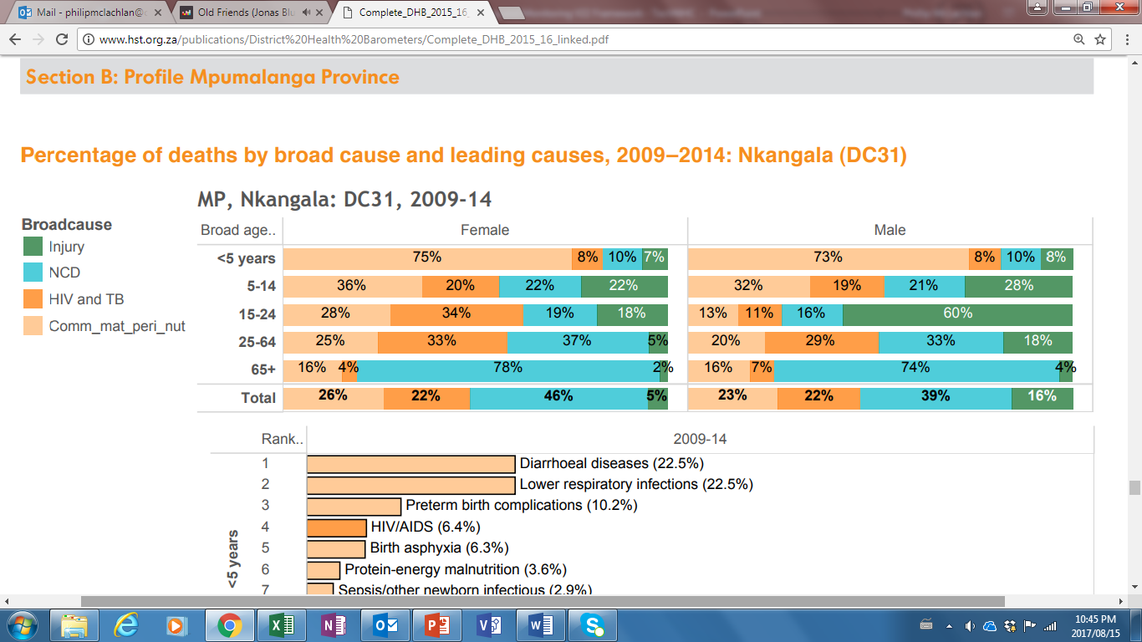

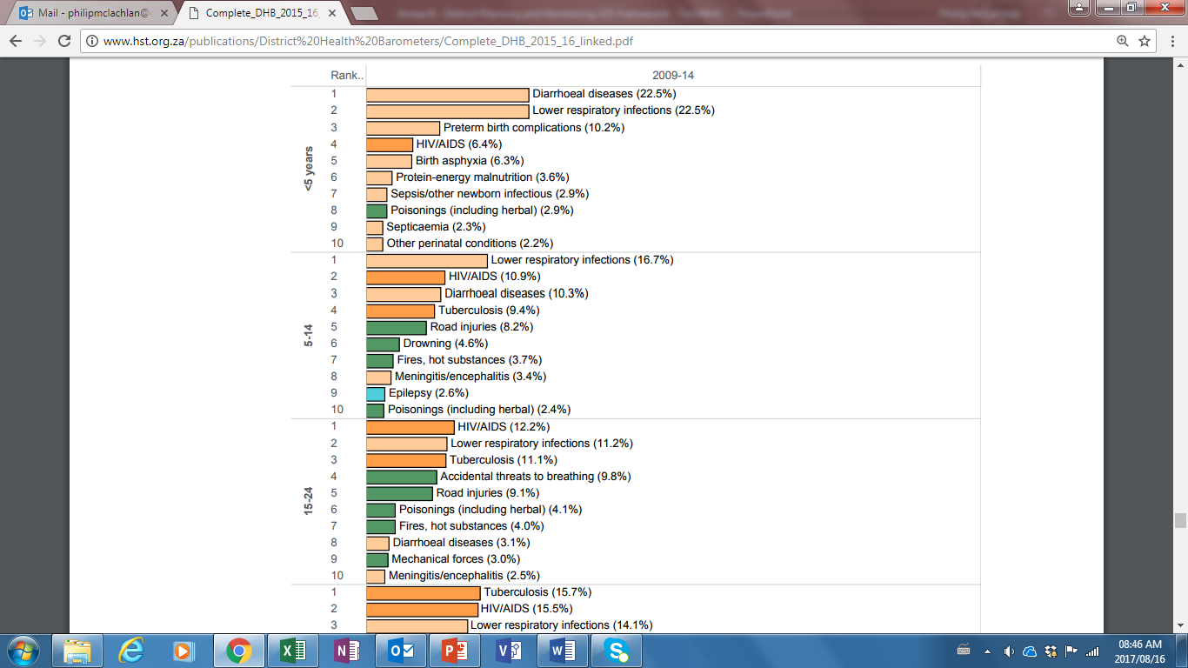

**Women and Maternal Health**

|  |  |  |  |  |  |  |  |  |  |
| --- | --- | --- | --- | --- | --- | --- | --- | --- | --- |
|  |  | Impact | Outcome | | Output | | | | |
|  | | Institutional maternal mortality ratio (Per 100K) | Delivery in facility under 18 years rate (%) | Antenatal client initiated on ART rate (%) | Mother postnatal visit within 6 days rate (%) | Antenatal 1st visit before 20 weeks rate (%) | Cervical screening coverage (%) | Couple year protection rate (%) |
|  | | 7 | 6 | 5 | 4 | 3 | 2 | 1 |
| King Dalindyebo | Indicator |  |  |  |  |  |  |  |
| Numerator |  |  |  |  |  |  |  |
| Denominator |  |  |  |  |  |  |  |
| Nyandeni | Indicator |  |  |  |  |  |  |  |
| Numerator |  |  |  |  |  |  |  |
| Denominator |  |  |  |  |  |  |  |
| Mhlontlo | Indicator |  |  |  |  |  |  |  |
| Numerator |  |  |  |  |  |  |  |
| Denominator |  |  |  |  |  |  |  |
| Qaukeni | Indicator |  |  |  |  |  |  |  |
| Numerator |  |  |  |  |  |  |  |
| Denominator |  |  |  |  |  |  |  |
| OR Tambo | Indicator |  |  |  |  |  |  |  |
| Numerator |  |  |  |  |  |  |  |
| Denominator |  |  |  |  |  |  |  |
| Eastern Cape | |  |  |  |  |  |  |  |
| RSA | |  |  |  |  |  |  |  |

**Annual trends**

**Child Health**

|  |  |  |  |  |  |  |  |  |  |  |  |  |  |  |  |  |  |  |  |
| --- | --- | --- | --- | --- | --- | --- | --- | --- | --- | --- | --- | --- | --- | --- | --- | --- | --- | --- | --- |
|  | |  | Impact | | | | | | | | Outcome | Output | | | | | | | |
|  | | | Child under 5 years diarrhoea case fatality rate (%) | Child under 5 years pneumonia case fatality rate % | Child under 5 years pneumonia case fatality rate % | Child under 5 years severe acute malnutrition case fatality rate % | Inpatient death < 1 year rate | Inpatient death < 5 years rate | Inpatient early neonatal death rate Per 1K | Inpatient neonatal death rate Per 1K | Infant 1st PCR test positive around 10 weeks rate (%) | School Grade 1 screening coverage (%) | School Grade 8 screening coverage (%) | HPV 1st dose coverage (%) | HPV 2nd dose coverage (%) | Vitamin A coverage 12-59 (%) | Immunisation coverage under 1 year (%) | Measles 2nd dose coverage (%) | Infant exclusively breastfed at DTaP-IPV-Hib-HBV 3rd dose rate (%) | |
|  | | | 17 | 16 | 15 | 14 | 13 | 12 | 11 | 10 | 9 | 8 | 7 | 6 | 5 | 4 | 3 | 2 | 1 | |
| King Dalindyebo | Indicator | |  |  |  |  |  |  |  |  |  |  |  |  |  |  |  |  |  | |
| Numerator | |  |  |  |  |  |  |  |  |  |  |  |  |  |  |  |  |  | |
| Denominator | |  |  |  |  |  |  |  |  |  |  |  |  |  |  |  |  |  | |
| Nyandeni | Indicator | |  |  |  |  |  |  |  |  |  |  |  |  |  |  |  |  |  | |
| Numerator | |  |  |  |  |  |  |  |  |  |  |  |  |  |  |  |  |  | |
| Denominator | |  |  |  |  |  |  |  |  |  |  |  |  |  |  |  |  |  | |
| Mhlontlo | Indicator | |  |  |  |  |  |  |  |  |  |  |  |  |  |  |  |  |  | |
| Numerator | |  |  |  |  |  |  |  |  |  |  |  |  |  |  |  |  |  | |
| Denominator | |  |  |  |  |  |  |  |  |  |  |  |  |  |  |  |  |  | |
| Qaukeni | Indicator | |  |  |  |  |  |  |  |  |  |  |  |  |  |  |  |  |  | |
| Numerator | |  |  |  |  |  |  |  |  |  |  |  |  |  |  |  |  |  | |
| Denominator | |  |  |  |  |  |  |  |  |  |  |  |  |  |  |  |  |  | |
| OR Tambo | Indicator | |  |  |  |  |  |  |  |  |  |  |  |  |  |  |  |  |  | |
| Numerator | |  |  |  |  |  |  |  |  |  |  |  |  |  |  |  |  |  | |
| Denominator | |  |  |  |  |  |  |  |  |  |  |  |  |  |  |  |  |  | |
| Eastern Cape | | |  |  |  |  |  |  |  |  |  |  |  |  |  |  |  |  |  | |
| RSA | | |  |  |  |  |  |  |  |  |  |  |  |  |  |  |  |  |  | |

**Annual trends**

**HIV**

|  |  |  |  |  |  |  |  |  |  |  |  |  |  |  |
| --- | --- | --- | --- | --- | --- | --- | --- | --- | --- | --- | --- | --- | --- | --- |
|  | |  | 3rd 90  **Outcome** | | | | 2nd 90  **Output** | | | 1st 90  **Process and Input** | | | | |
|  | | | Proportion Viral load done - Adult (%) | Proportion viral load done - Child (%) | Proportion Viral load suppressed - Adult (%) | Proportion Viral Load Suppressed - child (%) | Proportion remaining in care - Adults (%) | Proportion remaining in care - child (%) | Clients remaining on ART rate - all (%) | HIV test positive client 15 years and older rate (including ANC) (% | HIV testing coverage (including antenatal care) (%) | Medical male circumcision rate (%) | Male condom distribution coverage (condoms) | Female condom distribution coverage (condoms) |
|  | | | 12 | 11 | 10 | 9 | 8 | 7 | 6 | 5 | 4 | 3 | 2 | 1 |
| King Dalindyebo | Indicator | |  |  |  |  |  |  |  |  |  |  |  |  |
| Numerator | |  |  |  |  |  |  |  |  |  |  |  |  |
| Denominator | |  |  |  |  |  |  |  |  |  |  |  |  |
| Nyandeni | Indicator | |  |  |  |  |  |  |  |  |  |  |  |  |
| Numerator | |  |  |  |  |  |  |  |  |  |  |  |  |
| Denominator | |  |  |  |  |  |  |  |  |  |  |  |  |
| Mhlontlo | Indicator | |  |  |  |  |  |  |  |  |  |  |  |  |
| Numerator | |  |  |  |  |  |  |  |  |  |  |  |  |
| Denominator | |  |  |  |  |  |  |  |  |  |  |  |  |
| Qaukeni | Indicator | |  |  |  |  |  |  |  |  |  |  |  |  |
| Numerator | |  |  |  |  |  |  |  |  |  |  |  |  |
| Denominator | |  |  |  |  |  |  |  |  |  |  |  |  |
| OR Tambo | Indicator | |  |  |  |  |  |  |  |  |  |  |  |  |
| Numerator | |  |  |  |  |  |  |  |  |  |  |  |  |
| Denominator | |  |  |  |  |  |  |  |  |  |  |  |  |
| Eastern Cape | | |  |  |  |  |  |  |  |  |  |  |  |  |
| RSA | | |  |  |  |  |  |  |  |  |  |  |  |  |

**Annual trends**

**TB**

|  |  |  |  |  |  |  |  |  |  |  |  |  |
| --- | --- | --- | --- | --- | --- | --- | --- | --- | --- | --- | --- | --- |
|  |  | Impact | | Outcome | | | | | | | Output | Process |
|  | | TB death rate (ETR.net) (%) | Drug-resistant TB client death rate (%) | TB/HIV co-infected client on ART rate (ETR.Net) (%) | TB client treatment success rate (ETR.net) (%) | TB client loss to follow up rate (ETR.Net) (%) | TB rifampicin resistance confirmed client rate (%) | TB rifampicin resistant confirmed treatment start rate (%) | Drug-resistant TB treatment success rate (%) | Drug-resistant TB client loss to follow-up rate (%) | TB client initiated on treatment rate (%) | TB symptom 5 years and older screened in facility rate (%) |
|  | | 11 | 10 | 9 | 8 | 7 | 6 | 5 | 4 | 3 | 2 | 1 |
| King Dalindyebo | Indicator |  |  |  |  |  |  |  |  |  |  |  |
| Numerator |  |  |  |  |  |  |  |  |  |  |  |
| Denominator |  |  |  |  |  |  |  |  |  |  |  |
| Nyandeni | Indicator |  |  |  |  |  |  |  |  |  |  |  |
| Numerator |  |  |  |  |  |  |  |  |  |  |  |
| Denominator |  |  |  |  |  |  |  |  |  |  |  |
| Mhlontlo | Indicator |  |  |  |  |  |  |  |  |  |  |  |
| Numerator |  |  |  |  |  |  |  |  |  |  |  |
| Denominator |  |  |  |  |  |  |  |  |  |  |  |
| Qaukeni | Indicator |  |  |  |  |  |  |  |  |  |  |  |
| Numerator |  |  |  |  |  |  |  |  |  |  |  |
| Denominator |  |  |  |  |  |  |  |  |  |  |  |
| OR Tambo | Indicator |  |  |  |  |  |  |  |  |  |  |  |
| Numerator |  |  |  |  |  |  |  |  |  |  |  |
| Denominator |  |  |  |  |  |  |  |  |  |  |  |
| Eastern Cape | |  |  |  |  |  |  |  |  |  |  |  |
| RSA | |  |  |  |  |  |  |  |  |  |  |  |

**Annual trend**

**Non-communicable diseases**

|  |  |  |  |
| --- | --- | --- | --- |
|  |  | Outcome | |
| Sub-districts | | Hypertension incidence (Per 1K) | Diabetes incidence (Per 1K) |
|  | | 2 | 1 |
| King Dalindyebo | Indicator |  |  |
| Numerator |  |  |
| Denominator |  |  |
| Nyandeni | Indicator |  |  |
| Numerator |  |  |
| Denominator |  |  |
| Mhlontlo | Indicator |  |  |
| Numerator |  |  |
| Denominator |  |  |
| Qaukeni | Indicator |  |  |
| Numerator |  |  |
| Denominator |  |  |
| OR Tambo | Indicator |  |  |
| Numerator |  |  |
| Denominator |  |  |
| Eastern Cape | |  |  |
| RSA | |  |  |

**Annual trends**

# ANNEXURE D: PowerPoint slides for District Planning and Monitoring Framework, methods, process, and templates

The PowerPoint slide deck contains the entire guidelines. It may be used to facilitate discussions by District Management Teams to present the guidelines and facilitate strategic planning discussions.

These PowerPoint slides contain clearer images of all the figures used in these guidelines. The slides can be accessed through this link: <http://www.health.gov.za/DHP/>

1. Revised from Planning and Implementation of District Health Services, Chatora et., al. WHO, Module 4; 2004