South African National Essential Medicine List
Primary Healthcare Level Medication Review Process
Component: Emergencies and injuries
EVIDENCE SUMMARY

Date: 03 February 2021
Reviewers: Dr H Dawood and L Robertson*
Affiliation: Infectious diseases , Greys hospital and Caprisa, University of Kwazulu Natal
*Sedibeng District Health Services and Department of Psychiatry, University of the Witwatersrand

QUESTION: The optimum dose of thiamine for prevention and treatment of Wernicke’s encephalopathy and chronic alcohol misuse in the acute setting.
Background

In September 2020, a concern was raised by the Western Cape regarding IV administration of thiamine as supplier provides a caution of anaphylaxis in IV use – therefore only recommended for IM use.

The management of suspected alcohol withdrawal/ Wernicke’s encephalopathy under 21.2.4 Delirium in the PHC STGs was discussed at an ad hoc NEMLC meeting on 30 September. It was agreed to change the thiamine dose from Thiamine IV/IM 500mg immediately to Thiamine IM 100mg immediately. The decrease in dose was pragmatic, related to poor quality evidence for 500mg, variations in global practice, and thiamine available in 100mg/ml vials and 5ml IM injection unlikely to be tolerable.

At the Adult ERC meeting of 28 October 2020, a query was raised regarding the initial rationale for the 500mg dose with the concern that this was not discussed thoroughly when reducing the dose to 100mg.

High dose IV thiamine is still recommended in the Hospital Adult STGs in Chapter 14 Neurological Disorders: 14.2 DEMENTIA
Wernicke’s syndrome: E51.2 + (F02.8*)
- Thiamine, IV, 500 mg 12 hourly for 3 days, followed by 500 mg daily for 3–5 days.
- Follow with oral thiamine 100 mg 8 hourly.
IV thiamine is also recommended for ethanol poisoning in Chapter 19 (Thiamine, IV, 100 mg in 1 L dextrose 5%) only the dosing of thiamine in prevention and treatment of Wernicke’s encephalopathy is considered here.

Introduction

Wernicke’s encephalopathy (WE) is an acute neuropsychiatric condition due to overwhelming metabolic demands on cells that have depleted intracellular thiamine (vitamin B1) resulting in a reversible biochemical brain lesion. It is commonly seen in chronic alcohol misusers, and if treated sub-optimally with thiamine (given by the incorrect route, inadequate dose or too late), leads to irreversible structural changes producing loss of short-term memory and an impaired ability to acquire new information. Failure to treat WE leads to Korsakoff psychosis (KP), a chronic disease characterized by severe memory loss.

Treatment of WE with low parenteral doses of 50–100 mg of thiamine daily resulted in 16% full recovery, 17–20% died, and 84% developed KP. Of those with KP, only 21% showed complete recovery; 26% showed no improvement, 28% only slight improvement and 25% showed significant recovery from the amnesic state (can take between 2 months to 10 years).¹ It is therefore essential that thiamine be given as soon as possible in adequate amounts to all patients with suspected or incipient WE. The route of administration must provide sufficient supply of thiamine especially to the dependent enzymes in brain cells. In addition, all hypoglycaemic patients whether or not attributable to chronic alcohol misuse treated with IVI glucose must be given IVI thiamine at the same time to avoid the risk of precipitating WE.
Previous treatment of 500mg IV immediately in the PHC STGs for suspected alcohol withdrawal/ WE and current treatment of WE in Hospital Adult STGs based on empirical clinical practice and uncontrolled trials.¹⁻³
Clinical guidelines are vary in recommendations but generally use high doses for treatment (Table 1).⁴ NICE recommends thiamine is offered to people at risk of WE ‘in doses toward the upper end of the 'British national formulary' (BNF) range’ (https://www.nice.org.uk/guidance/qs11/chapter/quality-statement-10-wernickes-encephalopathy )
Summary of the evidence
- Prevention of WE
Cochrane Systematic Review by Day et al (2013) - one RCT (Ambrose et al., 2001) on prevention of cognitive dysfunction in alcohol withdrawal. 169 patients with alcohol dependence recruited from an inpatient detoxification unit were randomized to receive thiamine doses of 5mg, 50mg, 100mg, or 200mg IM once a day for 2 days. None had signs of WE. 107 patients included in analysis (43 did not complete treatment and data removed for 19 to equate groups for age, sex, and alcohol use). Only 200mg differed significantly from 5mg on cognitive testing post-treatment (mean difference (MD) -17.90, 95% confidence interval (CI) -35.4 to -0.40, P = 0.04).
No further RCTs for prevention or treatment of WE were identified in two recent systematic reviews, one investigating effect of nutritional interventions (McClean et al., 2020)⁵ and the other investigating treatment effects on alcohol related cognitive impairment (Caballeria et al, 2020)⁶
- Treatment of WE – prevention of Korsakoff’s psychosis
Uncontrolled trials noted by Thomson et al. (2002)¹ not referenced. Citation search of a 2007 Lancet review⁷ for trials recommending a minimum dose of 500mg IV three times a day for 3-5 days found reviews but no actual studies or data.
Case-series:
- Nshimoto et al. (2017)⁸ – retrospectively reviewed records of 11 patients with suspected or diagnosed WE and who had received high dose thiamine therapy, defined as ≥500mg parenteral thiamine per day. Doses of thiamine varied, including 500mg IV once off, daily, twice a day, and three times a day and duration from 1 to 7 days. Median time to treatment from symptom onset was 92hours.
Symptoms resolved in 7 out of 11 patients. No differences observed in those whose symptoms resolved vs those whose symptoms did not in terms of timing of thiamine initiation from symptom onset, patient variables, adverse effects. Conclusion: High-dose thiamine (≥500 mg) appears safe and efficacious for use in patients with suspected WE.
- Soler-González et al. (2014)⁹ – describe 10 cases in whom WE had been misdiagnosed and mistreated (time to diagnosis ranged from 2 – 44 days, average 22 days). Three received thiamine at low doses (100mg IM; 300mg oral). All showed at least some degree of improvement with IV thiamine 500 mg/8 h x 3 days, then 500 mg/day x 5 more days with at least 300 mg/day p.o.; some of them suffered severe consequences, mainly Korsakoff’s syndrome.
Conclusion
- Prevention of WE in alcohol withdrawal/ suspected alcohol withdrawal including hypoglycaemia – 200mg IM/IV should possibly be the minimum dose.
- Treatment of WE/ prevention of Korsakoff’s – no good evidence to support 500mg three times a day; 500mg once a day may be sufficient. Would be 5ml IM daily for 3 – 5days.
NEMLC MEETING OF 23 JUNE 2022:
NEMLC accepted the proposal to amend the dose of thiamine from “100mg” to “200mg”, aligned with available RCT evidence, for the prevention of Wernicke’s encephalopathy. NEMLC also deliberated on the route of administration and recommended that for the prevention of Wernicke’s encephalopathy, that thiamine should be administered intramuscularly and not by the intravenous route.

Table 1. Guideline comparison for prevention and treatment of WE (Latt and Dore, 2014)⁴
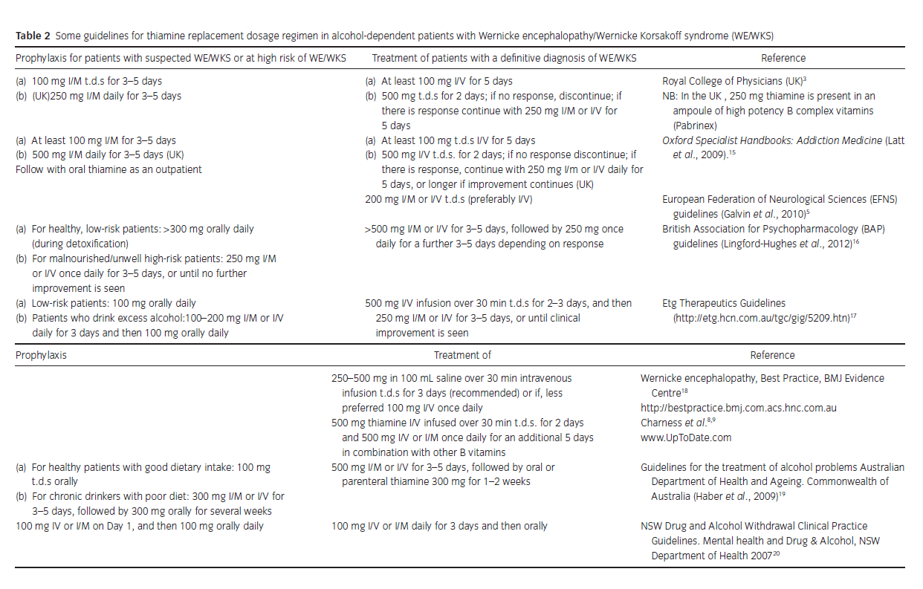

References

1. Thomson AD, Cook CC, Touquet R, Henry JA, Royal College of Physicians L. The Royal College of Physicians report on alcohol: guidelines for managing Wernicke's encephalopathy in the accident and Emergency Department. Alcohol Alcohol. 2002;37(6):513-21.10.1093/alcalc/37.6.513
2. Cook CC, Hallwood PM, Thomson AD. B Vitamin deficiency and neuropsychiatric syndromes in alcohol misuse. Alcohol Alcohol. 1998;33(4):317-36.10.1093/oxfordjournals.alcalc.a008400
3. Agabio R. Thiamine administration in alcohol-dependent patients. Alcohol Alcohol. 2005;40(2):155-6.10.1093/alcalc/agh106
4. Latt N, Dore G. Thiamine in the treatment of Wernicke encephalopathy in patients with alcohol use disorders. Intern Med J. 2014;44(9):911-5.10.1111/imj.12522
5. McLean C, Tapsell L, Grafenauer S, McMahon AT. Systematic review of nutritional interventions for people admitted to hospital for alcohol withdrawal. Nutr Diet. 2020;77(1):76-89.10.1111/1747-0080.12593
6. Caballeria E, Oliveras C, Nuno L, Balcells-Olivero M, Gual A, Lopez-Pelayo H. A systematic review of treatments for alcohol-related cognitive impairment: lessons from the past and gaps for future interventions. Psychol Med. 2020;50(13):2113-27.10.1017/S0033291720002925
7. Sechi G, Serra A. Wernicke's encephalopathy: new clinical settings and recent advances in diagnosis and management. The Lancet Neurology. 2007;6(5):442-55.10.1016/s1474-4422(07)70104-7
8. Nishimoto A, Usery J, Winton JC, Twilla J. High-dose Parenteral Thiamine in Treatment of Wernicke's Encephalopathy: Case Series and Review of the Literature. In Vivo. 2017;31(1):121-4.10.21873/invivo.11034
9. Soler-Gonzalez C, Saez-Penataro J, Balcells-Olivero M, Gual-Sole A. Wernicke-Korsakoff's syndrome: waiting for Godot? Alcohol Alcohol. 2014;49(1):117-8.10.1093/alcalc/agt124

